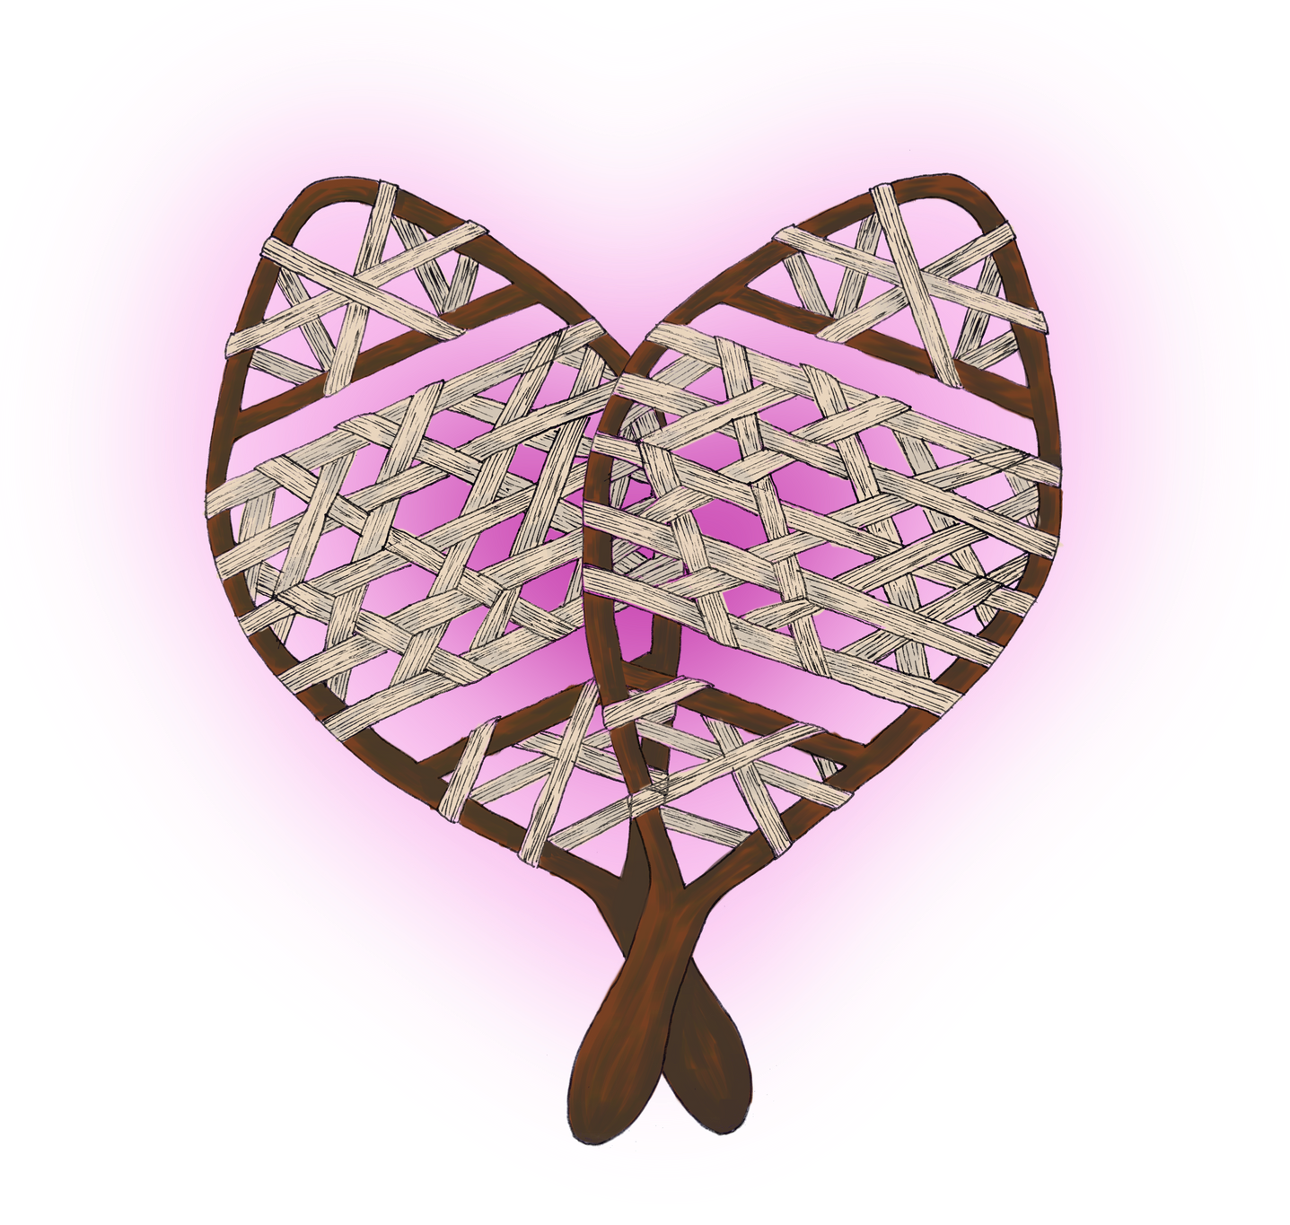
Cover Art by Esha Sawant
MeSH

WINTER 2026 EDITION


FOREWORD
We’re excited to reintroduce the Medical Student Happiness, Health, and Humanism (MeSH) Newsletter, a student-driven initiative dedicated to fostering open dialogue around mental health and well-being at the Renaissance School of Medicine.

Medical school is a journey filled with growth, challenges, and transformation. But it can also be isolating, overwhelming, and emotionally taxing. MeSH exists to remind us that we are not alone. Through shared stories, reflections, resources, and student voices, this newsletter aims to create a safe space for honest conversation, mutual support, and collective healing.

Mental health is not a side note, it’s foundational to our success as future clinicians and as human beings. By engaging with MeSH, we hope you’ll find connection, inspiration, and the courage to speak up, reach out, and support one another.

Welcome back to MeSH! Let’s keep the conversation going.


Dr. Cohen & Dr. Wackett
Editor in Chief: Christina Jacob
Managing Editor: Sravya Varanasi Co-Editor & Web Editor: Becka Konnayil Art & Visual Media Editor: Esha Sawant
2
Design & Layout Editor: Lekha Yaramada

TABLE OF CONTENTS

COZY WINTER RECIPE 4
Hannah Hesson

BOOK/SHOW/ALBUM REC.
Sara Turku Sravya Varanasi Christina Jacob
COMMUNITY RESOURCE SPOTLIGHT
Michael Petagna

PET SPOTLIGHT
Steve Dobrioglo

JUST KEEP SWIMMING
Becka Konnayil
THE CREATIVE RESET
Lekha Yaramada

LITTLE GREEN HOUSE
Amaavi Miriyagalla
PHOTOGRAPHS OF WINTER
Belle Lin A FELT ABSENCE
Cooper Maselli

AFFIRMATIONS
Erica Lin

BEYOND FLASHCARDS AND FORMALDEHYDE: REFLECTIONS FROM A FIRST-YEAR MEDICAL
STUDENT
Mia Kotikovski
5-6

7

8

8

9

10

11

12-13

14

15

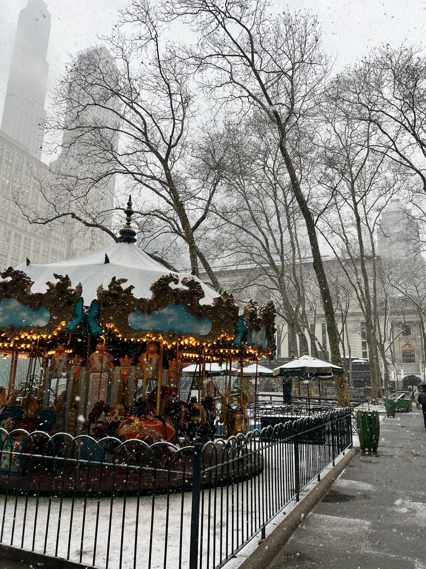
Photo by Belle Lin

LIVELIHOOD AT RSOM: 16 STUDENT LOUNGE
Henna Chaudhry
WHAT IF WE GAVE JOY A CHANCE? 17
Oluwatofunmi Musa-Ajakaiye
3

Cozy Winter Recipe

Hannah Hesson
Nothing soothes the soul like a warm and hearty soup simmering on the stovetop when it’s icy and brisk outside. This recipe is near and dear to me, as it was created by my very best friend, someone who embodies wellness and who has taught me over the years to prioritize my own. Whip this soup up when you’re feeling stressed, or simply just need a hug in a bowl. From my archives to yours, enjoy!

INGREDIENTS

- A healthy glug of olive oil
- 16oz of lean ground chicken
- Seasoning to taste:
- Salt + pepper
- Italian seasoning — basil, parsley, and oregano (dried or fresh)
- Red pepper flakes or Calabrian chili paste, whatever you prefer!
- Classic mirepoix — approximately 1 onion, 4 stalks of celery and 4 peeled carrots evenly diced
- As much fresh minced garlic as your heart desires
- 1/4 cup of butter
- Teaspoon of flour
- 48oz of low sodium chicken broth – I like to use chicken bouillon as opposed to box stock
- 16oz of potato gnocchi
- A healthy handful of kale
- A dash of heavy cream
- Parmesan for topping

INSTRUCTIONS
Step 1: In your favorite soup pot on medium heat, add your olive oil and ground chicken. Break the chicken apart into bite-sized pieces (avoiding making it too fine) and season for the whole soup with your Italian spices.

Step 2: Once that’s browned, mix in your mirepoix and let it set for about 2-3 minutes before addling the garlic. Let it all cook down for a few more minutes, stirring occasionally.

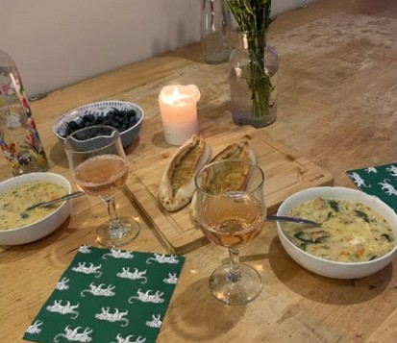
Step 3: Next, make a little pocket in the middle of the pan, drop in the butter, and let it melt. Add a teaspoon of flour on top of the melted butter and make a little roux in the middle of your veggies and chicken. Once it’s combined, give the whole mixture a big stir. Continue to stir occasionally for about a minute so the flour can cook and coat your mixture.
Step 4: Add in your chicken broth and turn up the heat. Bring it to a boil, then down to a simmer until the vegetables are a little soft — about 10 minutes, give or take.

Step 5: Add your gnocchi and cook for an additional 5 minutes. Halfway through, add your kale. Once the gnocchi are cooked and the kale has softened, add a dash of heavy cream to taste. Let it sit on low heat for a little bit, so it all comes together.

Step 6: Top with parm! Serve with crusty bread and your beverage of choice.
4 Cheers!

BOOK REC

PEOPLE WE MEET ON VACATION

Sara Turku


The warmth of the sun on your face, a gentle breeze that pushes nagging wisps of hair out of your eyesight, and the sounds of waves crashing against the shore. This is what it feels like to read “People You Meet on Vacation”. Emily Henry burst onto the romance scene with her debut romance “Beach Read” and solidified her place in the world with her second hit “People You Meet on Vacation”.



The story of Poppy and Alex, two best friends who schedule one week out of every year to go on vacation together. The two polar opposites, fun and outgoing Poppy, and reserved and shy Alex, meet by coincidence and build a friendship that seems picture-perfect… until one summer. Two years later we see them try to get back to what once was while grappling with the emotions they have skirted around for years. The timeline flips back and forth from the present summer to all their adventures in the past and we get to see the underlying intricacies of who they are together as well as alone. One of Henry’s strengths is her characterization and that is no different for Poppy and Alex. They aren’t one dimensional stereotypes but complex people that you can see yourself, or maybe someone you've never met before, in. Their struggles and joys and love feel real. Love that leaves you smiling when you finish the book. While, the will-they-won’t-they might not be everyone's cup of tea, I implore you to give it a try. It might just speak to you (you’ll get this reference later).

P.S. There is a movie based on this out on Netflix! A wonderful watch but read the book first!

5

SHOW & ALBUM REC


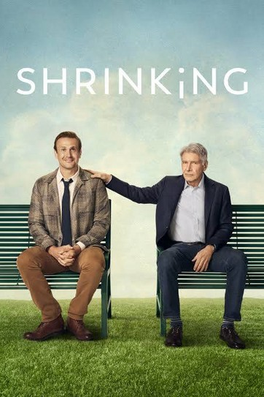
SHRINKING

Sravya Varanasi

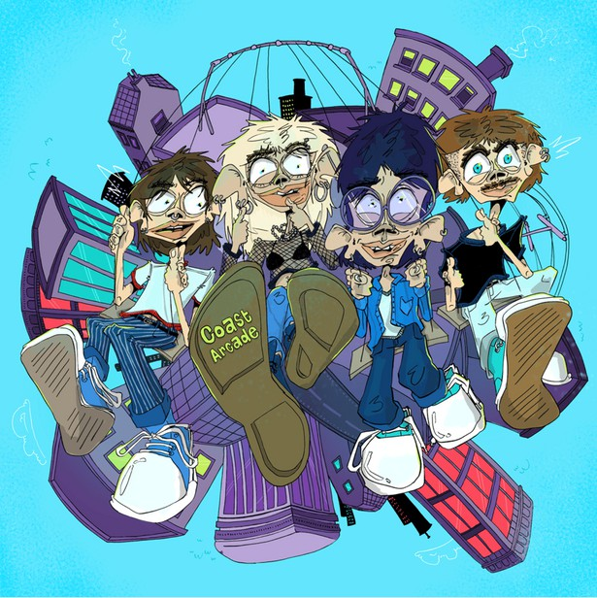
Are you looking for a show that makes you shriek with laughter, gasp with shock, and also appreciate how people find a way to keep moving through life? Then I highly recommend Shrinking on Apple TV starring Jason Segel and Harrison Ford! The show follows a grieving therapist (Jimmy) who decides to abandon the careful rules of the patient-therapist relationship and start telling his patients what he really thinks. While this sounds like a recipe for disaster, the show does an incredible job of showing how Jimmy navigates his grief, while also being a significant support to his patients (albeit in unconventional ways). The show features a stellar cast whose chemistry will make you appreciate the friends and family you have in your own life. My favorite part of the show is its portrayal of therapy and mental health that feels human rather than awkward or clinical. It’s the kind of show that feels comforting while also gently pushing you to be a little kinder to yourself and others.
6

COAST ARCADE

Christina Jacob
If you’re looking for new bands and new genres to explore, check out Coast Arcade’s debut album! Featuring a mix of indie rock/pop and surf rock, their songs are perfect for late drives back from the hospital, long study sessions, or when you just want a break to discover new music! You’ll be blasted with sun-soaked guitar melodies and energetic drum rhythms, warming you up this winter and reminding you better weather lies ahead!
The show premiered in 2023, but season 3 premieres this year, so now is a perfect time to catch up!



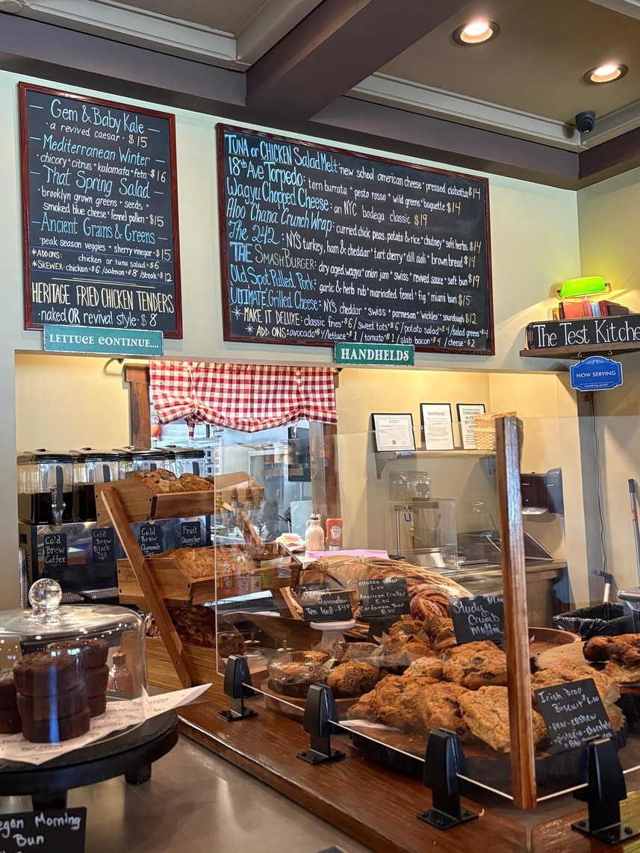

Resource Spotlight
Michael Petagna

The Study
Mon-Fri 8am - 7pm
Sat 9am - 7pm Sun 9am - 3pm
100-27 S Jersey Ave, Setauket- East Setauket, NY 11733
Coffee, Tea, Food, Studying, and Fun
Located behind the Stop & Shop in Setauket is a fun, new, and study-friendly cafe. Enjoy coffee, tea, pasteries, breakfast, burgers and more while studying or chatting with friends in a relaxed environment. They also have live music on Saturdays from 4pm-7pm and a cocktail bar!

The Meditation Room
ID Access 24/7
HSC5 (directly the the left of the lactation pods)
Balancing Your Emotions
Take a short break from your studies or shift and step into the Meditation Room across from the cafeteria. It’s a calm space to pause, listen to music, meditate, breathe, and slow down.

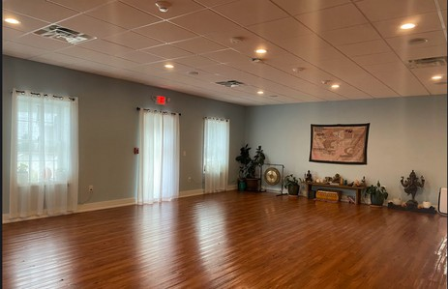

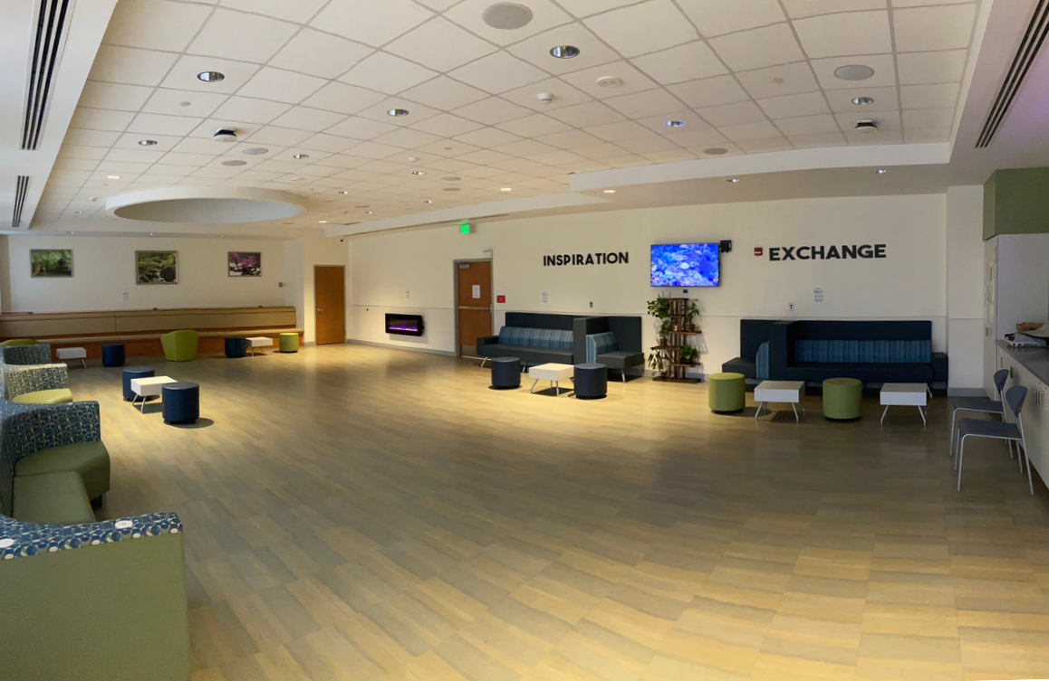

The Mindful Turtle
60 NY-25A, Setauket- East Setauket, NY 11733 https://www.mindfulturtle.com/classes/schedule/
Find Your Center
Enjoy yoga classes with excellent instructors for
$15 with a student pass. They offer 9 different class styles depending on your intensity preference. Choose from Restorative Yoga, Yin Yoga, Slow Flow, Ashtanga, Active Vinyasa and more. They are very beginner friendly!

7

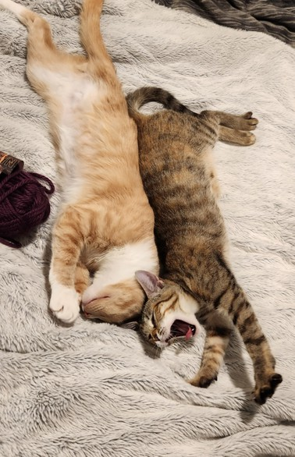

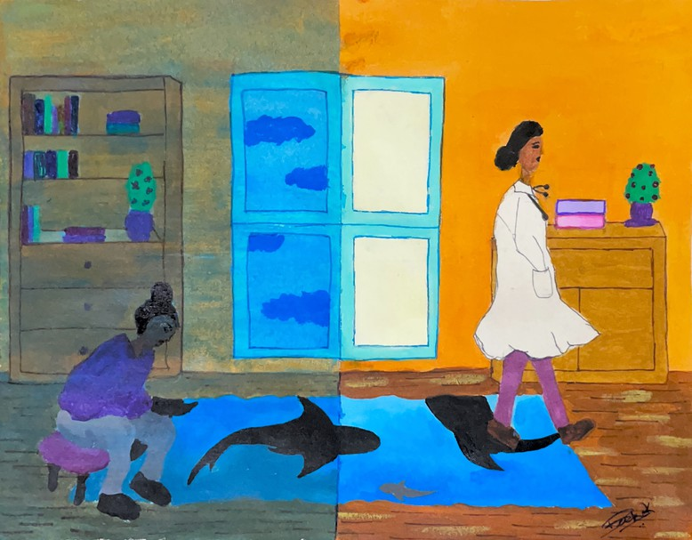
JUST KEEP SWIMMING
Becka Konnayil

PET SPOTLIGHT

Steven Dobrioglo
“Having both of them (Xena and Remy) around has definitely done wonders for my own health - simply seeing the extent of their friendship every day is such a joy. But when you add in their ability to provide distraction when needed, their quiet reassurance while I study, and constant greetings at the front door (no matter how late I come back home), they've provided endless support even through the hardest times.”

8

THE CREATIVE RESET

Lekha Yaramada

Alongside exercise, rest, and social connection, creativity serves as a simple yet effective tool for stress relief. Whether it’s drawing, painting, sculpting, or playing an instrument, short sessions throughout the week can promote emotional awareness and thoughtful reflection.

Art benefits not only the mind but also the body. Research shows that engaging in creative expression for as little as 45 minutes significantly decreases cortisol levels, the body’s primary stress hormone.[1] For medical students who are regularly exposed to high-pressure situations, art provides a way to improve mood and restore emotional balance after a difficult day.

Most importantly, you don’t have to be experienced or a natural talent to reap the benefits of art and creative expression. The joy comes from the process of creation itself, not the outcome. Art doesn’t need to be displayed or judged by anyone. Creativity allows for freedom of expression without comparison or evaluations.

Creativity can also be shared. Art nights, music sessions, or creative workshops with friends can help us connect with others while engaging in stress-relieving activities.

As we nurture our creative side, we allow ourselves to settle into a different headspace and create an outlet to reflect, connecting with our identity beyond academic pressures. We shift away from performance mode and into an exploratory, curious frame of mind. By making time and space for creativity, we give ourselves an emotional outlet to fall back on throughout our careers.

Ideas to get started- no experience needed:
- Pick a household object to sketch
- Use coloring books or digital coloring apps
- Follow along with painting tutorials

- Take a walk- photograph anything that captures your eye
- Follow tutorials for origami or clay sculpting
- Create a vision board- physical or digital
- Write letters to yourself or loved ones

1. Kaimal, G., K. Ray, and J. Muniz, Reduction of Cortisol Levels and Participants' Responses Following Art Making. Art Therapy, 2016. 33(2): p. 74-80.

9

LITTLE GREEN HOUSE

Amaavi Miriyagalla



Early last year,
My big asked me to join her on a beach walk. To park by Crazy Beans in historic Stony Brook, And meander along the shore for a while.
I heard somewhere that gazing at a body of water can soothe you.
Lower your blood pressure, Or heart rate maybe.
I think I believe it.

I came back with two new friends a few months later,
To show them where I felt calm here, On Long Island.
We sat on the docks for a while, And just took in the waves.

When we made it to the end of the sand,
We looked across at the West Meadow Beach trail. There’s a little green house there,
And it always looks so precious, Perched on the deep blue water. We wondered if we could get to it.

10
And then it was June,
On the precipice of our last summer. We were in good company,
And the tide was really low.
We walked further than we ever had before, And the little green house looked so close.
Less of a swim, But still,
A swim.

I know I can just park at West Meadow Beach, Walk along the trail,
And visit the little green house from there, If I want to.
But I think,
I want to keep returning to this beach walk, With people I care deeply about,
To maybe,
Make it from this end.



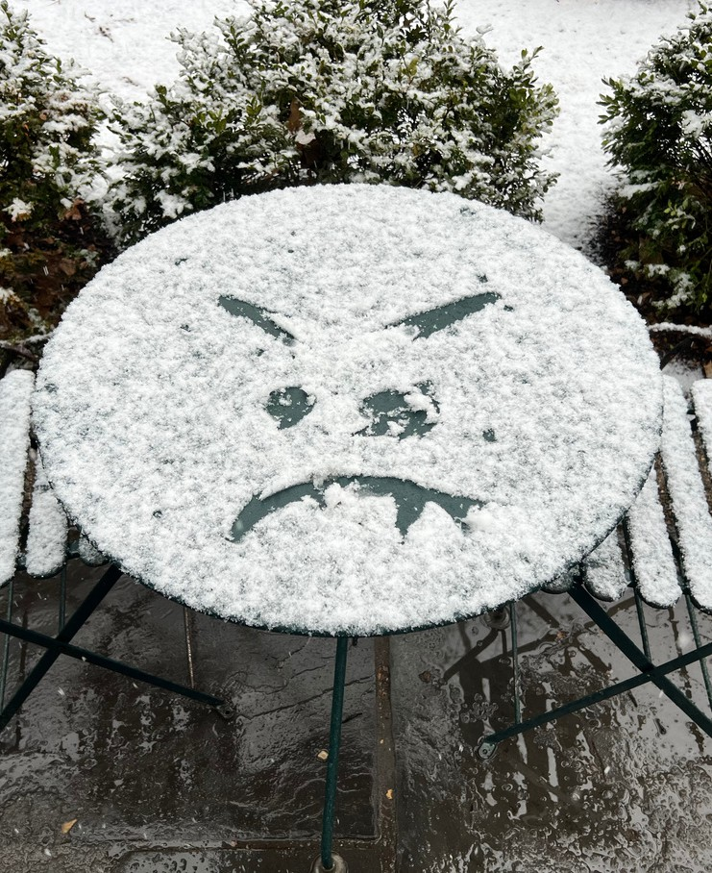
Photographs of Winter Belle Lin
11


A FELT ABSENCE

Suicide Prevention and What We Leave Untaught

Cooper Maselli
Medicine trains relentlessly to prevent death. Upon entering medical school, trainees are taught to recognize life-threatening conditions. We learn to connect the outputs of an EKG with the underlying pathophysiology of potentially fatal arrhythmias. To recognize the electrical signature of Torsades de Pointes is not enough. One must understand the heart’s intrinsic pacemaker circuitry and the role of potassium ion channels to correct the arrhythmia when it occurs. In medicine, no depth is too deep to be probed in pursuit of greater understanding. Yet not all areas of medicine are examined with this same rigor. Practical training in suicide prevention remains conspicuously absent from medical education.

Most medical trainees receive minimal instruction on how to ask about suicidal thoughts, and even less preparation for navigating these conversations when patients disclose them. Without formal guidance and practice, trainees struggle to feel confident in assessing risk. It is therefore unsurprising that clinicians may reflexively urge hospitalization, rather than considering autonomy, upon learning that a patient is experiencing suicidal ideation (SI).

To lack training in assessing suicide risk is to treat SI as a monolith rather than a diverse landscape in which thoughts and actions are not inherently linked. Many individuals live with chronic suicidal thoughts without ever acting on them, while others require inpatient care to remain safe. Developing sound clinical judgment in this domain requires formal education and deliberate practice. Without it, medicine cannot meaningfully progress in its care of suicidal patients.
What we are not taught matters. Gaps in training do more than leave physicians underprepared. They contribute to the stigmatization of mental health. When suicide prevention is omitted from the medical curriculum, suicidal thoughts are implicitly treated as something other than a legitimate medical concern.

At scale, patients bear the greatest effect. Many avoid disclosing suicidal thoughts out of fear that doing so will lead directly to involuntary hospitalization. More devastating still, this omission exists within the context of a physician suicide epidemic. Roughly one in ten medical students report experiencing SI during training (Rotenstein et al.). Suicide remains a leading cause of death among young adults, and evidence suggests that physicians experience a significantly elevated risk. These patterns are not mysterious. They reflect well-described features of medical training: chronic exposure to distress, stigma around vulnerability, fear of professional consequences, and inadequate preparation to assess suicidal risk.
12


A FELT ABSENCE

Suicide Prevention and What We Leave Untaught

(continued)
There is something uniquely tragic about physician suicide. Those most committed to promoting health and well-being lose their lives from deprivation of the very care they set out to provide. These deaths are not failures of resilience, but reflections of a system that has forgotten its own humanity.

This is not an indictment of individual physicians. Rather, it is an acknowledgment that progress remains possible. Medicine has transformed once-fatal conditions before, and it can do so again. The next time we hear of a resident suicide, we must not allow our heartbreak to be accompanied by perplexity. We know why this is happening. What remains is whether we are willing to act.

Citation:

1. Rotenstein LS, Ramos MA, Torre M, Segal JB, Peluso MJ, Guille C, Sen S, Mata DA. Prevalence of Depression, Depressive Symptoms, and Suicidal Ideation Among Medical Students: A Systematic Review and Meta-Analysis. JAMA. 2016 Dec 6;316(21):2214-2236. doi: 10.1001/jama.2016.17324. PMID: 27923088; PMCID: PMC5613659.

13

AFFIRMATIONS

Erica Lin


Doctor? I hardly know her! Subscapular? I hardly know her!
Polymeric immunoglobulin receptor? I hardly know her!
Ureter? I hardly know her! Cofactor? I hardly know her! Centrilobular? I hardly know her! Blood donor? I hardly know her! Alan Turner? I hardly know her! annular? I hardly know her!
Retractor? I hardly know her! Klinefelter? I hardly know her! Ticagrelor? I hardly know her!
ADP receptor inhibitor? I hardly know her! Tissue plasminogen activator? I hardly know her! Intravascular? I hardly know her!
Tissue factor? I hardly know her! Blood pressure? I hardly know her! Liver? I hardly know her!
(said kind of weirdly) IFN-y? I hardly know ‘a! Calor? Dolor? Tumor? Rubor? I hardly know her! Fever? I hardly know her!
Monomer? I hardly know her! ER? I hardly know her!
Columnar? I hardly know her!
Von Willebrand Factor? I hardly know her! Substance use disorder? I hardly know her! Catheter? I hardly know her!
Druthers? I hardly know hers! Code Lavender? I hardly know her! Auricular? I hardly know her!

14
Tender? I hardly know her!
Tongue depressor? I hardly know her! Femur? I hardly know her!
Bedside manner? I hardly know her! Extensor? I hardly know her!
Flexor? I hardly know her! Pronator? I hardly know her! Supinator? I hardly know her! Bernard-Soulier? I hardly know her! Ventricular? I hardly know her!
Cherry red spot, macular? I hardly know her! Gastric sphincter? I hardly know her!
Testicular? I hardly know her!
Sterno-clavicular? I hardly know her! Molar? I hardly know her!
Posture? I hardly know her! Alveolar? I hardly know her! Erector (spinae)? I hardly know her! Vestibular? I hardly know her!
Extraocular? I hardly know her!
(said weirdly) Middle ear? I hardly know her! Employee meal? 6 dollar? I hardly know her! Murmur? I hardly know her!
GIIb/IIIa receptor? I hardly know her!
Dirt in my eye, can’t chew a cracker? I hardly know her!
LIRR? I hardly know her! Floaters? I hardly know her! Failure? I hardly know her!

By Erica? I hardly know her.

BEYOND FLASHCARDS AND FORMALDEHYDE:
REFLECTIONS FROM A FIRST-YEAR MEDICAL STUDENT

Mia Kotikovski

I entered medical school excited, motivated, and with profound gratitude for finally stepping into the dream I had been pursuing for years. What I didn’t expect was how quickly my life would become consumed by the lingering smell of formaldehyde and an Anki deck that behaves like a mind-boggling magic trick– cards disappear for a second, then reappear doubled the next day. Most days, it feels like there’s always more to do, and figuring out when enough is truly enough can be challenging. The academic demands are intense in a way that’s hard to explain to anyone who hasn’t experienced it, even when the material is endlessly fascinating and meaningful.

Over the first few months, long hours in the cadaver lab, late nights with flashcards, and disrupted sleep were slowly chipping away at my previously balanced lifestyle and habits. Before I realized it, time with family, friends, and the things that ground me started to disappear. The truth, I’m discovering, is that feeling overwhelmed is a normal part of medical school, and talking about it has shown me I’m far from alone.

However, it’s becoming clear to me that my own well-being shapes how I learn and how I’ll care for patients in the future. When I’m exhausted or drained, it’s harder to focus, stay curious, or be fully present; when I’m grounded and supported, learning feels lighter and more meaningful.
Lately, I’ve been trying to make small but intentional changes. I’ve learned how important it is for me to spend time with loved ones who fill me with good energy and positivity, even when it feels like I “should” be studying. I’m paying more attention to eating balanced meals, instead of surviving on coffee and snacks from TJs– while very tasty, definitely not sustainable. And I always try to have something to look forward to, a fun weekend plan in the city, travel plans to Europe over the upcoming break, or even a simple dinner with friends– something that reminds me that life exists past the lecture halls and HSC library.

These first few months of medical school have taught me that caring for others in medicine begins with caring for ourselves. Prioritizing mental health sustains us, strengthens learning, and shapes the empathetic, resilient physicians we aspire to be.

15

LIVELIHOOD AT RSOM:
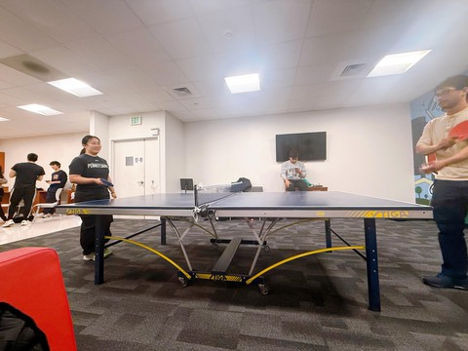
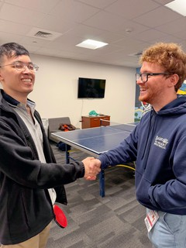
STUDENT LOUNGE

Henna Chaudhry

Traversing through the Renaissance School of Medicine, one can find many places that are strictly business: numerous classrooms, the HSC library, the infamous anatomy lab, and surprisingly enough, multiple escalators. With many medical students across all four years, surely there must be a place for leisure?

Almost hidden along a lengthy hallway of lockers is the student lounge, home to a television set, comfortable couches, and a whopping seven microwaves. Seasoned Stony Brook-ers often remark on the elusiveness of this space: “I didn’t even know this place existed,” says Christain Reilly, a Stony Brook alum and now M1. Despite being out of sight, the student lounge has become a hot spot for medical students to spend their lunch breaks, decompress in between classes, and has even become a prime location for hosting holiday Pot Luck and White Elephant parties.

However, the student lounge wasn’t always like this. Over the past year, efforts spearheaded by Haeun Jung, M2 class senator, have transformed the previously crowded lounge into a lively, usable space that has attracted students from all years. Previously, “no one wanted to be here,” states Lindsey Browning, also an M2. But in the summer of 2025, around 10 M2’s as well as Dr. Cohen redesigned this space to something beyond its former glory. “There were old books everywhere and we worked hard to clean up everything,” Browning continues, “Now it’s so spacious and I’m glad to see people gathering here!”

16

One of the important discoveries uncovered in this grand effort is a humble ping pong table. Upon first sight, most M1 students passed it by, as remarked by Dani Bhashyam, “I thought nothing of it.” Others saw its potential: “I was excited and had started to look for classmates to play ping pong with,” says Andrew Tran. Soon enough, ping pong had become a recurring hobby among M1’s. “Although anatomy lab was tough,” Aryan Ghotra admits, “I’m glad I had a chance to play a fun game with friends right after.”

Eventually, the lounge traffic inspired M1 athletic chair Patrik Goncalves to host a ping pong tournament. With over 12 matches hosted so far, the tournament is still ongoing, attracting new players every day. “Everyone is willing to teach and help each other,” states Melody Cheng. Benjamin Kim agrees, “You know the saying in Ratatouille that anyone can cook? Well, anyone can play ping pong.”

Overall, M1 students and beyond revel in having a shared space. Succinctly put into words by M1 class senator Xuan Lin: “the medical student lounge is a valuable space because it allows us to connect, unwind, and build a sense of community.” Students belonging from different states and/or countries can all find their space in the lounge, and this space continues to attract newcomers every day. And as said by M1’s Jasmeen Kaur and Gianna Montante, enjoying this common student lounge with fellow classmates is like having “a family away from home.”


WHAT IF WE GAVE JOY A CHANCE?

Oluwatofunmi Musa-Ajakaiye
We have all been sucked into a trap without our permission. We’ve been made to believe that the proof of hard work is fatigue displayed through a negative outlook on life. Within medicine’s high-stress environment, the trap tightens, and we become easier prey.

So, when someone asks me, “How are you doing?" I skim through the records of my day and pull out a solid “not bad” or “could be worse” from my repertoire of experiences. My undone decks of Anki cards seem to regenerate every time I think I have finished them. The next NBME is in a week and my brain feels empty.

The truth, though, is that I had a delicious avocado toast with warm hot cocoa for breakfast. I called my mom during my lunch break, and we reminisced on some shenanigans I pulled off as a kid to avoid eating my veggies. Tonight, my roommates and I plan to pop some corn and watch our favorite T.V. show until it’s time for bed.

You’re probably wondering, “Where’s she going with this?” I will explain. My point is that being joyful is oftentimes a choice we make. It is not blissful ignorance or denial of the difficulties of daily living. It is a conscious effort to celebrate the little miracles we get to experience.

What if we start focusing on the positive parts of our days? What if we give joy a chance? Answering a “how are you?” with “I’m good! I had a delightful breakfast this morning!” or “I am a little tired to be honest, BUT I am looking forward to [insert something good that’s coming up for you]! (Don’t say there’s nothing! I’m sure you can come up with at least one thing that’s even remotely exciting.)

I know it might sound like a quirky exercise, but it might just be your chance to spread a little joy and get some in return!

17

Stay warm this winter!

Photograph by Belle Lin

CHECK OUT OUR WEBSITE TO SEE ALL OUR PUBLISHED WORKS!


HTTPS://WWW.STONYBROOK.EDU/COMMCMS/ BIOETHICS/EDUCATION/MESH

