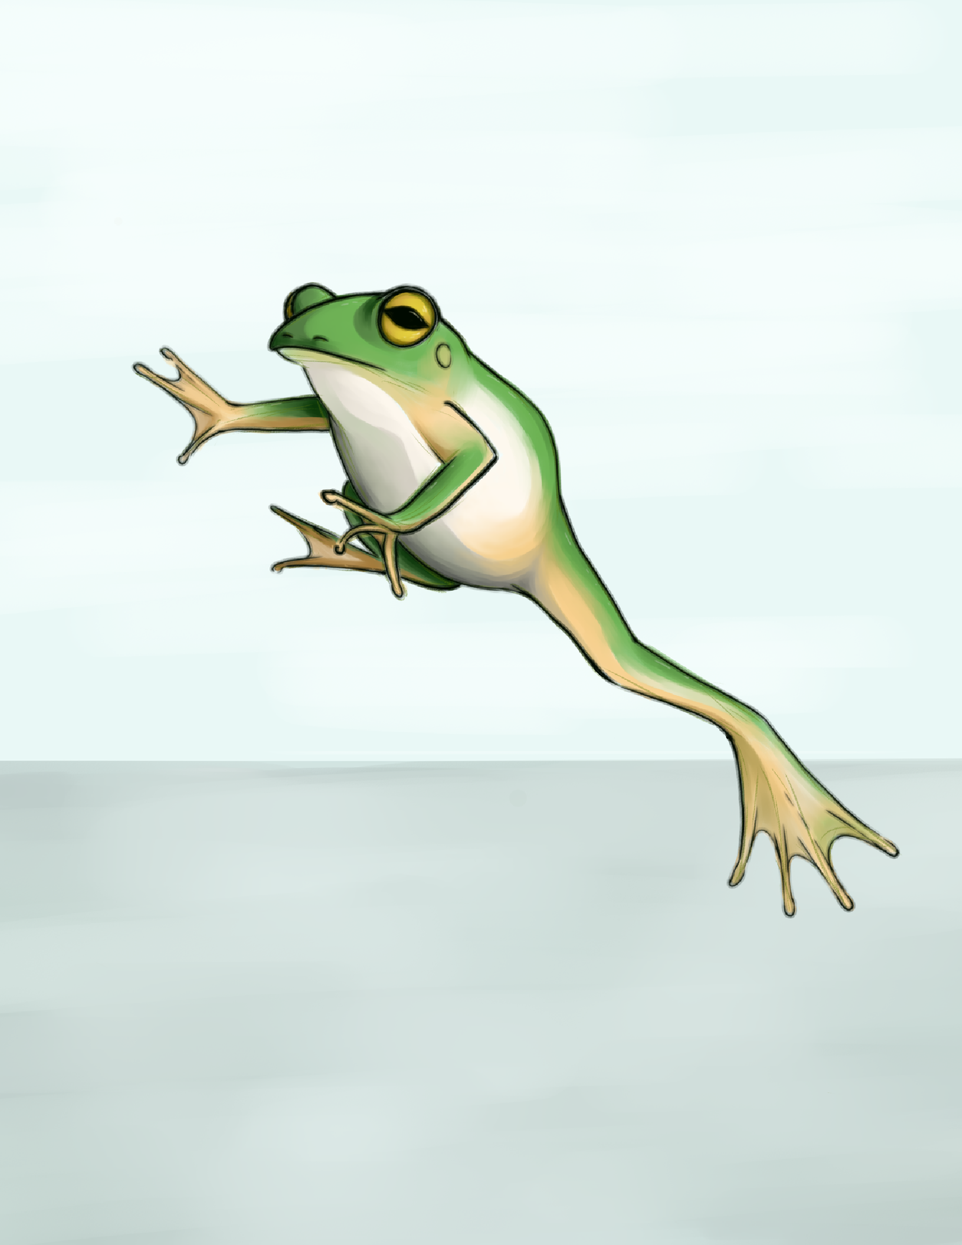
LEAP FORWARD
MeSH
SPRING 2026 EDITION

Cover Art Esha Sawant

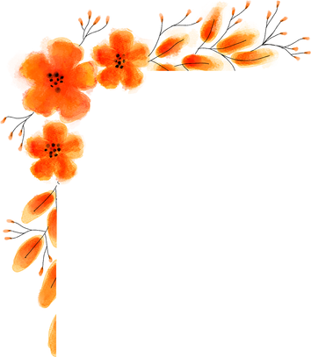
FOREWORD
I’m so grateful to offer a few words of introduction to the Spring 2026 issue of the Medical Student Happiness, Health, and Humanism (MeSH) Newsletter, a student-driven initiative dedicated to fostering open dialogue around mental health and well-being at the Renaissance School of Medicine.
In medical school, springtime brings a promise of warmer weather, new growth and experiences, and successful completion of academic milestones. It can also be a time of overwhelming stress and uncertainty. If the opening line of T.S. Eliot’s poem, The Waste Land (1922), claims “April is the cruelest month,” one might suggest that in med school Spring is the cruelest season.
How do we stay centered in the present moment in times of great uncertainty and stress? The pieces featured in every MeSH newsletter aim to support us in doing just that. Whether it’s a gorgeous photograph or graphic created by a classmate, a story, essay or poem that seems like it was written just for you, a recipe, life-hack, book rec, show or movie review that’s offered as a love-language, the works in MeSH remind us that we are not alone. They help pull us out of the negative rumination over past mistakes and keep us from anxiously catastrophizing about what’s coming up next.
Firmly rooted in medical student experience, the MeSH newsletter keeps us grounded in the present moment, each piece focusing our attention on specific details, representing unique points of view with universal applicability, and connecting us with what it means to be a human being even in times of uncertainty, change and growth.
To quote the great mindfulness-meditation teacher, Jon Kabat-Zinn, “As long as you are breathing there is more right with you than wrong with you, no matter what is wrong.”
The same goes for the honest conversations and safe spaces of MeSH. As long as you are engaged with MeSH as an artist, editor, writer or reader, there’s more right with you than wrong with you, no matter what is wrong.
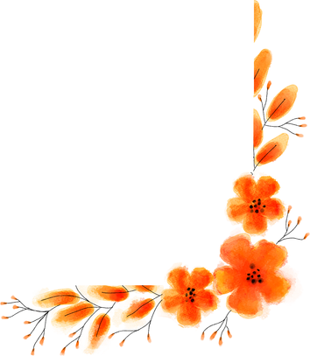
Dr. Maria Basile Center for Medical Humanities, Compassionate Care and Bioethics

Editor in Chief: Christina Jacob Managing Editor: Sravya Varanasi
Co-Editor & Web Editor: Becka Konnayil
Art & Visual Media Editor: Esha Sawant
2
Design & Layout Editor: Lekha Yaramada

TABLE OF CONTENTS

FROM WINTER TO WARMTH: MY MASLENITSA STORY
Mia Kotikovski

BOOK/SHOW/ALBUM REC.
Amaavi Miriyagalla Christina Jacob Hannah Hesson

RESOURCE SPOTLIGHT: SEAWOLVES PANTRY
Oluwatofunmi Musa-Ajakaiye

THINGS I HAVE DONE SINCE FINISHING MY STEP EXAMS
Sravya Varanasi

TO SAY GOODBYE
Cooper Maselli

A BLOOMING DAFFODIL
Christina Jacob

PHOTOGRAPHS OF SPRING
Belle Lin

ANOTHER SIDE: A 55-WORD STORY
Becka Jill Konnayil
4-5

6-7

8

9

10

11

12-13

14

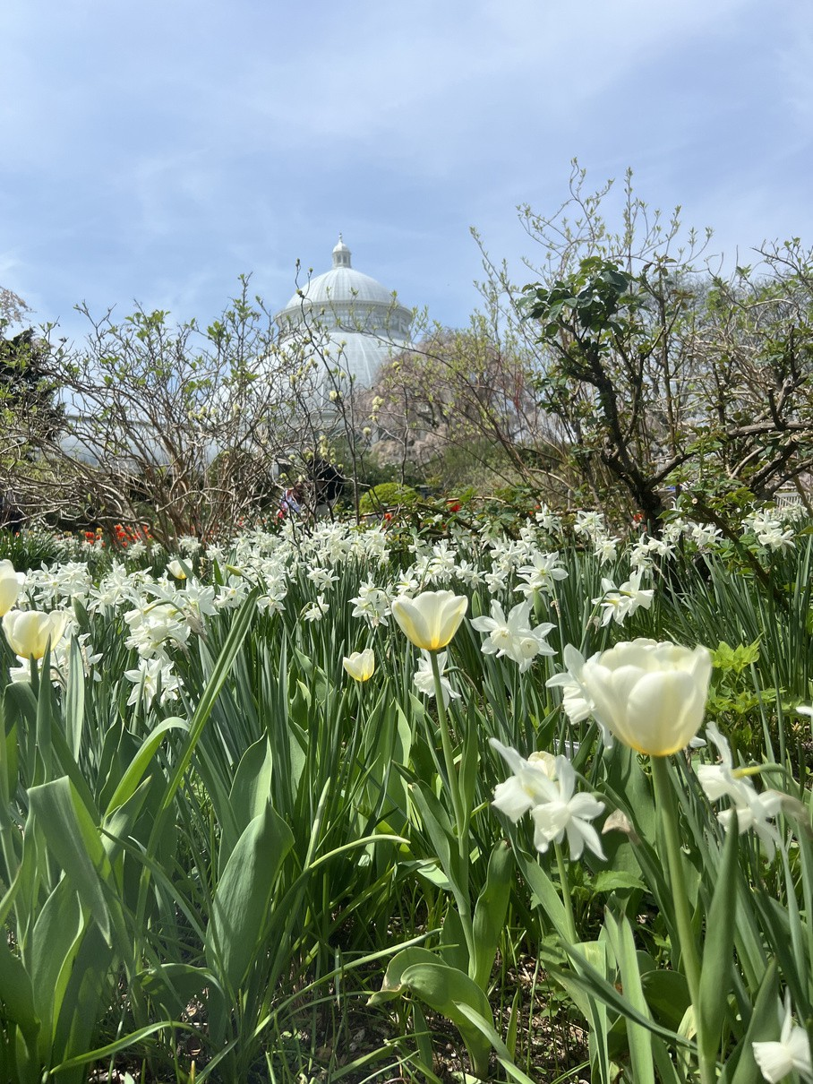
Photograph by Belle Lin

MEET YOURSELF 15
Michael L Petagna

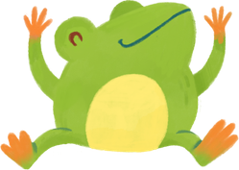

3

From Winter to Warmth: My Maslenitsa Story
Mia Kotikovski

Maslenitsa was always one of the most meaningful weeks of the year in our Soviet household– not because winter was ending, but because of what the week represented. The word Maslenitsa comes from the Russian word “maslo,” meaning butter. While it does have some religious origins, the celebration marked the Slavic farewell to winter and the welcoming of the sun, which is why blini, round and golden, became its symbol. My family immigrated from the former Soviet Union, where holidays were often downplayed due to religious oppression, yet Maslenitsa endured– reframed as a celebration of heritage rather than faith.

In our family, Maslenitsa meant honoring Slavic roots, preserving customs that survived political change, and practicing generosity regardless of circumstance. The blini were thin and ever-so-slightly crunchy at the edges, cooked quickly in a well-seasoned pan. We’d stand by the stove, brushing each one with melted butter as it came off the heat, eating them almost as quickly as they were made! Maslenitsa taught us that culture lives in repetition– in recipes passed down, in stories retold, and in the simple ritual of feeding whoever walks through the door.

INGREDIENTS INSTRUCTIONS

- 2 cups all-purpose flour
- 2 eggs
- 21⁄2 cups milk (warm)
- 1 tbsp sugar
- 1⁄2 tsp salt
- 2 tbsp melted butter or oil (plus more for the pan)
  - Whisk eggs, sugar, and salt.
  - Gradually add milk and flour, whisking until smooth and thin (similar to heavy cream).
  - Stir in melted butter.
  - Heat a lightly buttered pan over medium heat.
  - Pour a small ladle of batter, swirling to coat the pan thinly.
  - Cook 1–2 minutes per side until lightly golden.
  - Stack and keep covered with a towel to stay soft.

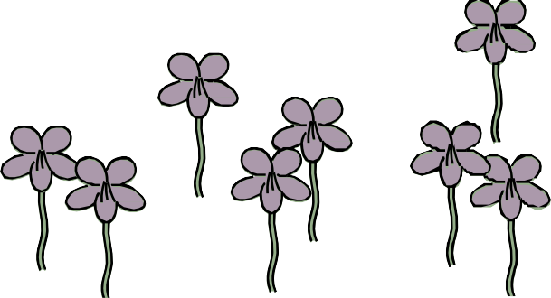
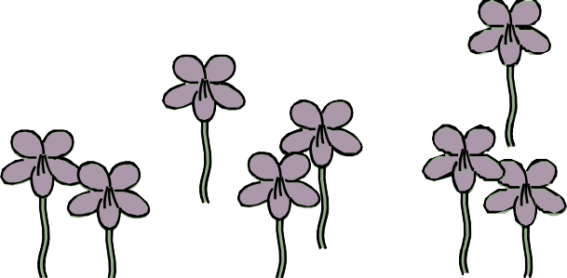
4

From Winter to Warmth: My Maslenitsa Story
Mia Kotikovski

Some Unique Slavic Fillings:
Beyond the usual jam and sour cream, here are some more traditional and distinctive options:

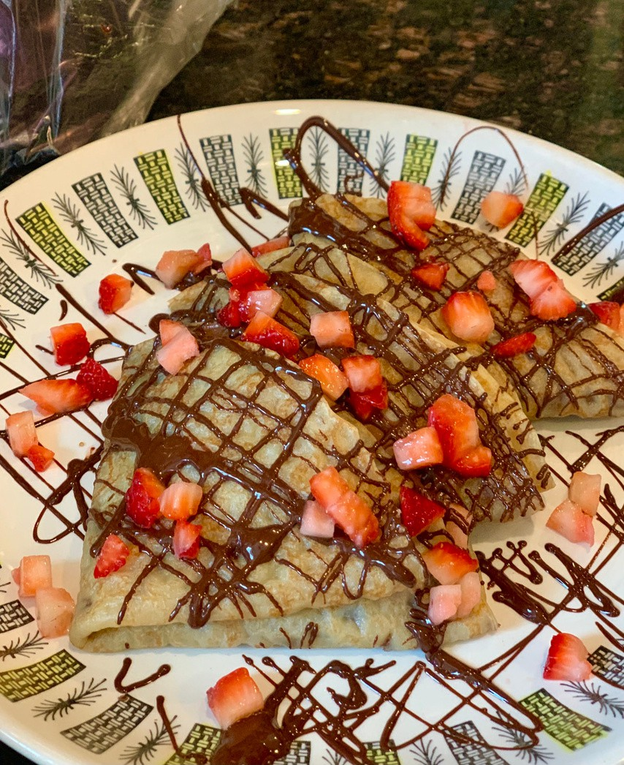
Savory:
- Farmer’s cheese (tvorog) with fresh dill and garlic
- Sautéed mushrooms and onions (my personal favorite!)
- Smoked salmon or red caviar with sour cream

Sweet:
- Sweetened tvorog with sour cherry preserves
- Condensed milk (a Soviet childhood favorite)

Maslenitsa, whether celebrated in Russia, Ukraine, or across the former Soviet diaspora, remains a celebration of warmer weather returning. In my family, it’s still the smell of butter in a hot pan and the comforting reminder that no matter how long or harsh the winter may be, spring– and another blin– is always on its way.
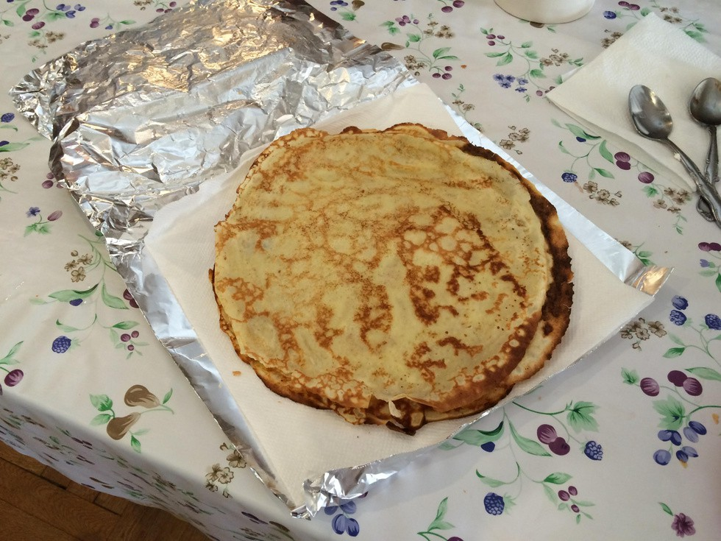

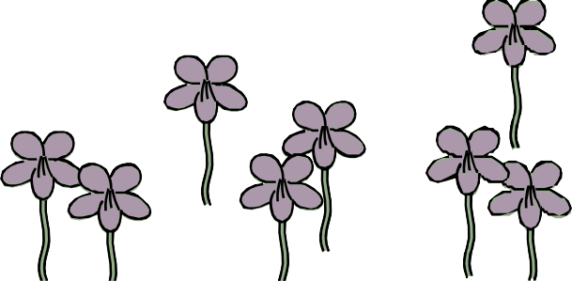
5

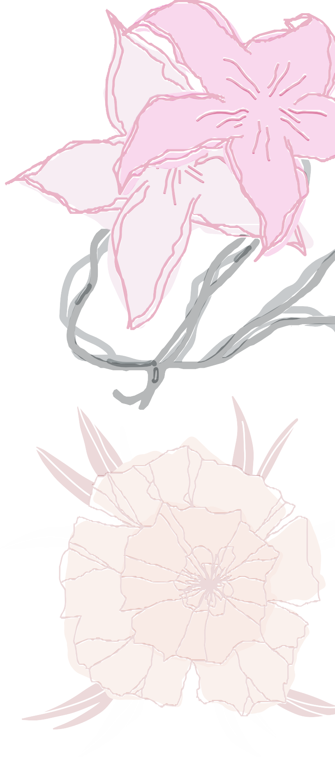
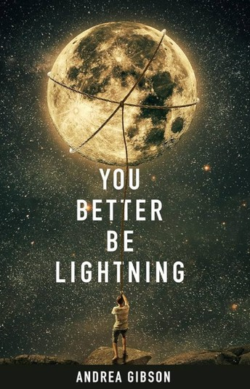
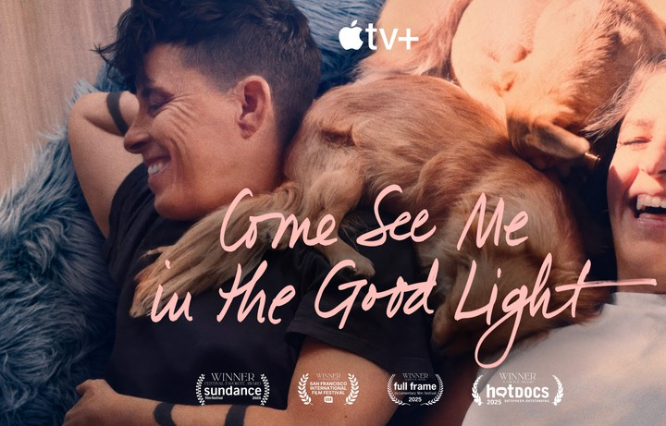
BOOK REC

YOU BETTER BE LIGHTNING
Amaavi Miriyagalla

This collection of poetry by Andrea Gibson really touched me when I picked it up for the first time last summer. They weave deeply personal explorations of their life, love, and illness with broader musings on the wonder of this earth and the place we make for ourselves within it. There is a softness, a tenderness, to their writing that I think feels especially grounding in the current global and political climate. In particular, they manage to directly challenge systems of oppression while maintaining their signature gentleness and vulnerability. Love is always at the center of their work.

You Better Be Lightning can be whatever kind of reading experience you want, or have the capacity for right now: a quick read, a poem a night for a month or so, or a work you come back to again and again. It also feels especially accessible to me; sometimes people are intimated by poetry collections for fear that they will be more confusing than enjoyable, but this book just invites you in.

Andrea was a prominent spoken word poet as well as Colorado’s 2023 poet laureate, and their work also shines beautifully in the Apple TV documentary, Come See Me in the Good Light. Andrea lost their battle with ovarian cancer last year, and this documentary chronicles their journey through love, illness, and loss, alongside their partner Meg. It is deeply moving, and their poetry is spoken aloud in the background of many of the scenes. Certainly a worthy watch, either before or after you read You Better Be Lightning.
6

SHOW & ALBUM REC

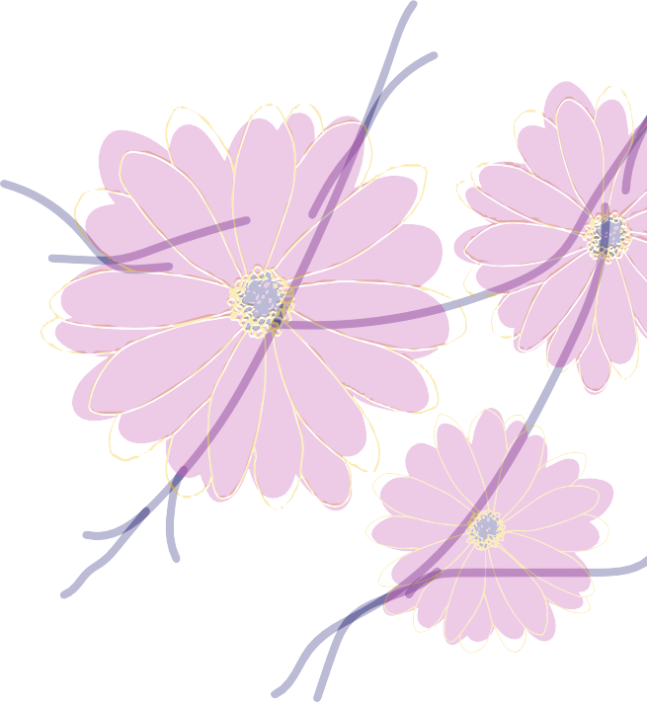

PROJECT HAIL MARY
Christina Jacob
Adapted from the novel by Andy Weir, author of The Martian, this movie brings you to a world like Interstellar, but layered with endless heart and humor. As you watch the 2.5 hours fly by aboard the Hail Mary, you’ll find yourself falling in love with a surprisingly adorable “Rocky”, humming along to Sign of the Times (karaoke version), and realizing, despite all odds, a happy ending can still be within reach—even if it’s not the one you originally imagined.

BUCKINGHAM NICKS
Hannah Hesson
For dedicated fans of the beloved and iconic Fleetwood Mac who grew up singing along to classics such as “Landslide”, “Dreams”, and “Everywhere”, we’ve got a lesser-known hidden gem to reveal to you! A short history lesson - prior to joining Fleetwood Mac, the duo of Lindsey Buckingham and Stevie Nicks created and released an album in September 1973 titled “Buckingham Nicks”. This legendary album, at the time, actually performed quite poorly commercially. The duo found themselves struggling financially. Soon enough, however, producer Keith Olsen played the song “Frozen Love” for Mick Fleetwood during a visit to Sound City Studios. As the band was transitioning members, Fleetwood invited Buckingham to join the band. Lindsey Buckingham agreed on one condition,
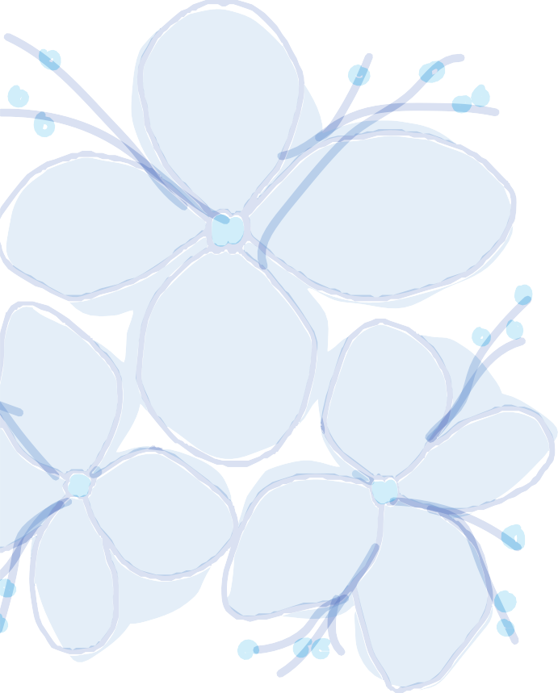
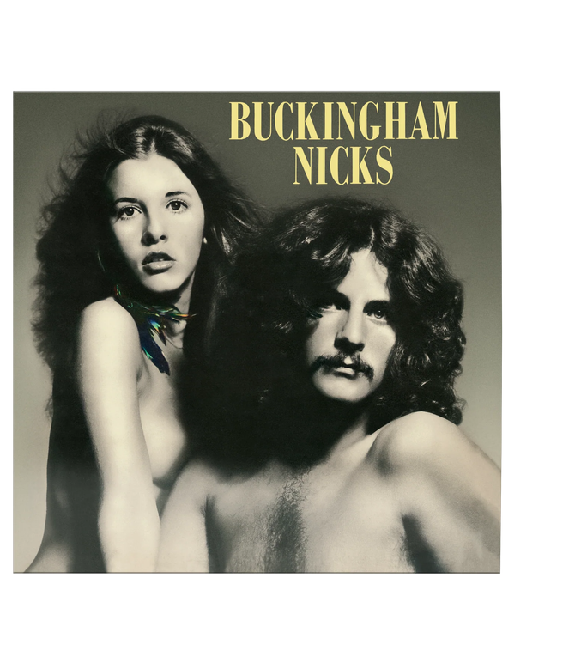
that Stevie Nicks be along for the ride.

The folk-rock sound of “Buckingham Nicks” is equal parts whimsical, earthy, ethereal, and intimate. This album is seen somewhat as an “origin story” for Fleetwood Mac’s impactful repertoire of rock classics. For years, the album was particularly difficult to access, lending to its obscurity and “cult classic” designation. However, after decades of fans searching for this relic, Stevie Nicks and Lindsey Buckingham officially announced the reissue and the album was re-released to major streaming platforms in September 2025.
The hunt is over! Hop on Spotify, rediscover and redefine your appreciation for Fleetwood Mac with this hauntingly
formative album.
7

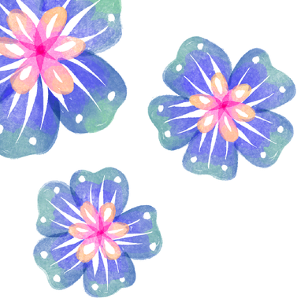

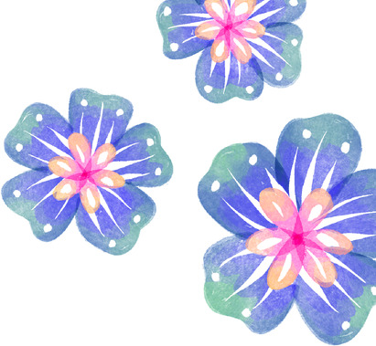
Resource Spotlight: Seawolves Pantry
Oluwatofunmi Musa-Ajakaiye

Free food is a medical student’s love language, as we all know experientially. The Stonybrook “Seawolves” Pantry brings the love by providing free meals including sandwiches, salads, fruit, yogurt cups and other items. Besides already-cooked food, they also have lots of staples you can use in preparing meals at home like pasta, canned beans, vegetables, tuna, and tomato sauce. They are located in the basement of the Student Union opposite East Side dining on the East Campus. You can easily get there by taking the Express East bus from HSC. Their hours are 12pm-4pm on Monday to Friday (closed during the weekend). You can also help support students on campus who might be experiencing food insecurity by donating to the pantry.

All this information and more is available on their website at: https://www.stonybrook.edu/commcms/foodpantry/index.php !

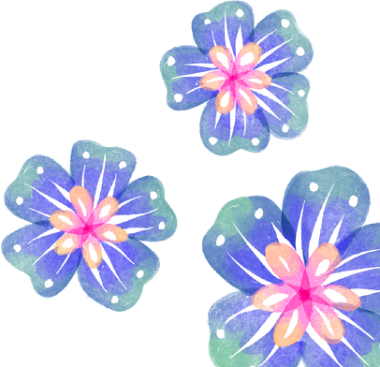
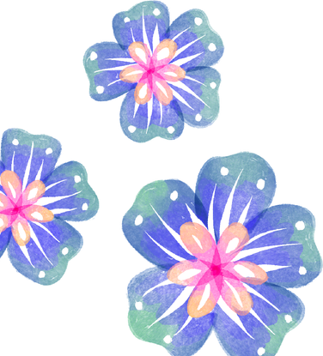
I hope you check it out!
8

THINGS I HAVE DONE SINCE FINISHING MY
STEP EXAMS:
Sravya Varanasi
- Finished a book
- Finished another book
- Spent way too much time playing Tomodachi Life
- Went on a 3-mile walk
- Deleted Anki from my homescreen
- Went on another 3-mile walk
- Just sat on the couch and did nothing, knowing I had nothing to do
- Stared at the sun
- Immediately regretted staring at the sun 10. Stopped to smell the flowers…literally

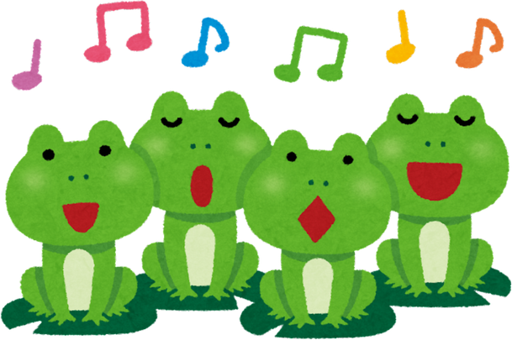
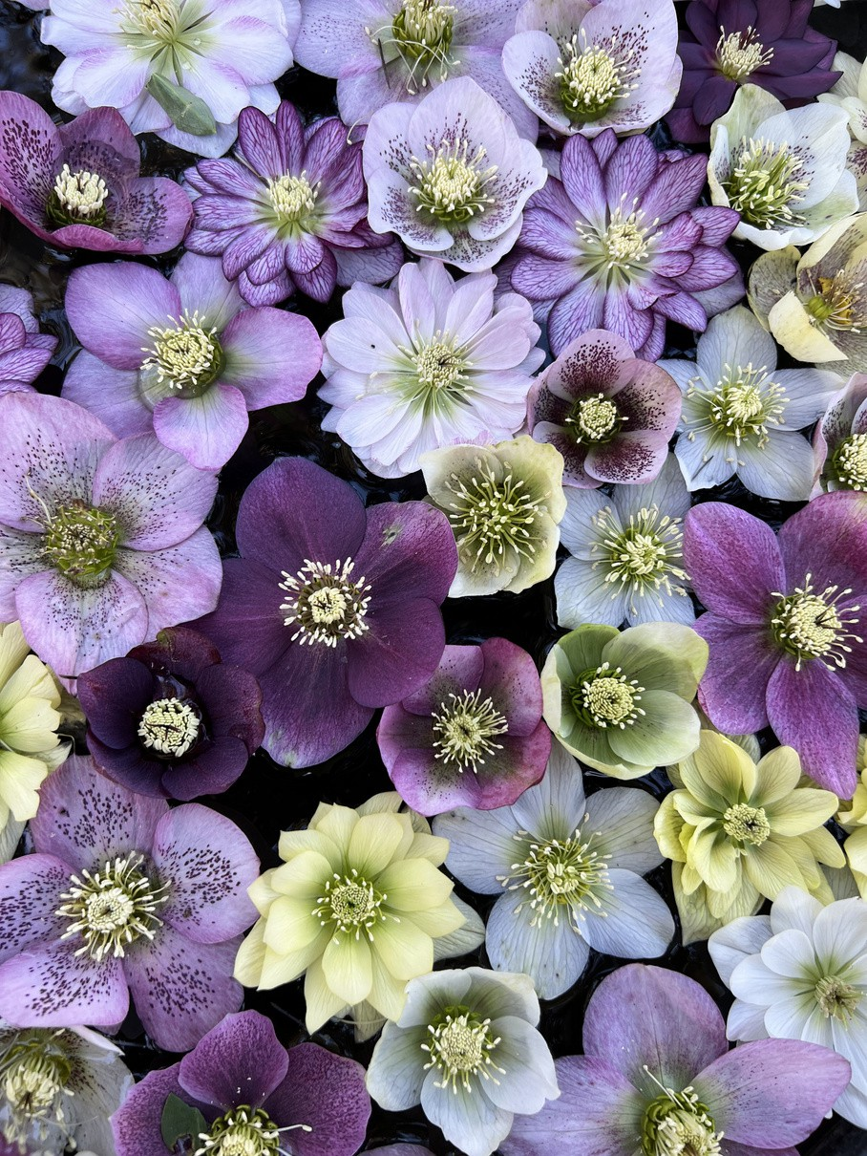
Photograph by Belle Lin
9


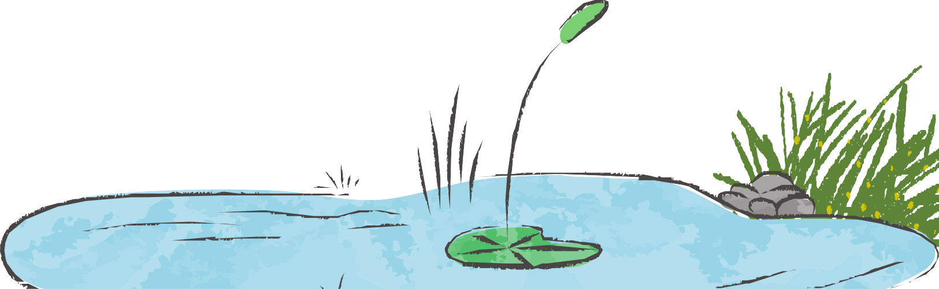
TO SAY GOODBYE
Cooper Maselli

I don't dislike many things in life, though I hate saying goodbye. To say goodbye is to acknowledge that something has ended — that time has landed on the last node in a finite sequence.

Recently, life reminded me that finitude is not negotiable. I unknowingly landed on a final node. My burden was to say goodbye to my beloved dog, Ollie.

What rushed through my mind was telling. I was inundated with questions of "lasts." When was the last time I threw Ollie a tennis ball? When was the last time I saw him really run? When was the last time I gave him the final bite of my Sunday morning bagel? These questions slowly morphed away from time and towards intention. Why hadn't I played more tug of war with him? Why hadn't I brought him for more car rides? It wasn't long before guilt, anger, and crushing sadness surfaced.

So in that final hour, I tracked the rise and fall of his chest and absorbed the kindness his eyes had always radiated. I pinched his ears lightly between my fingers and traced the ridge of his nose, desperate to hold onto these memories of him. With closed eyes, I watched how fleeting they truly were.

To say goodbye to Ollie was to confront that everything in life happens a last time. I hope this fact has an enduring effect on me because I want to live differently.

10

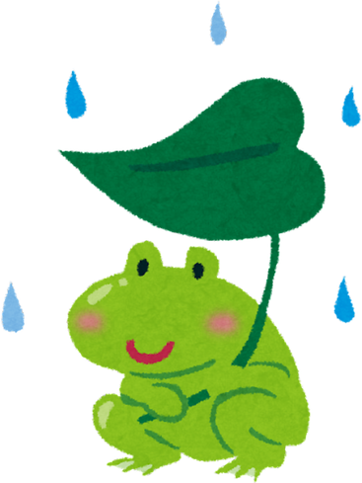
A BLOOMING DAFFODIL
Christina Jacob

The sun shone, reflecting light off my mirror into my eyes
Opened the door and was met with bright colored petals, their hues nature’s prize

The grass warmed under the clear sky Feeling foreign after the endless ice
My blanket lay under the weeping tree growing high
Sheltering ants and spiders, their quiet paradise

Disappearing with the long winter Was the last of the snow
Their blanket of silence no longer lingers In their absence, a daffodil begins to grow
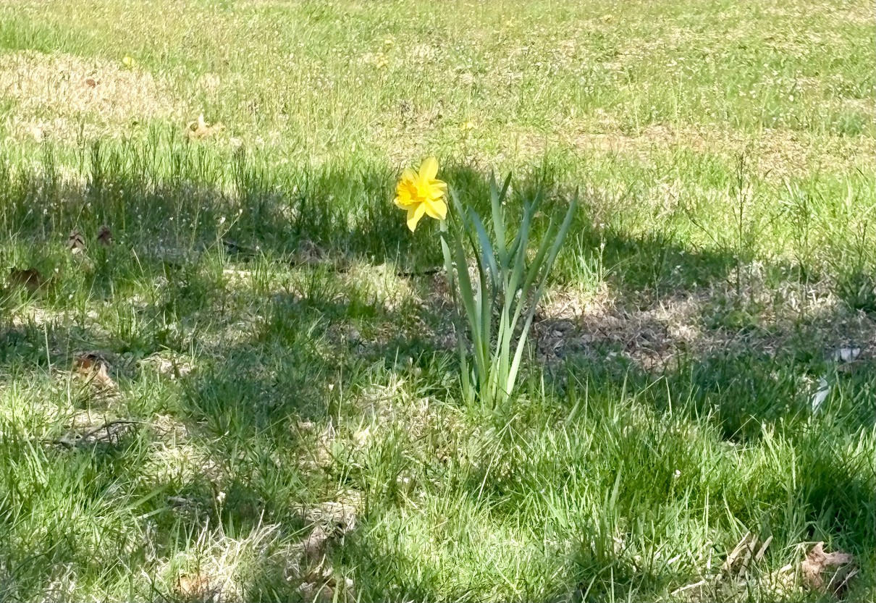
11

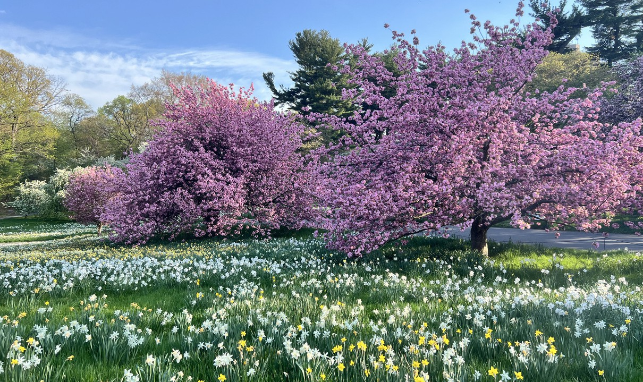
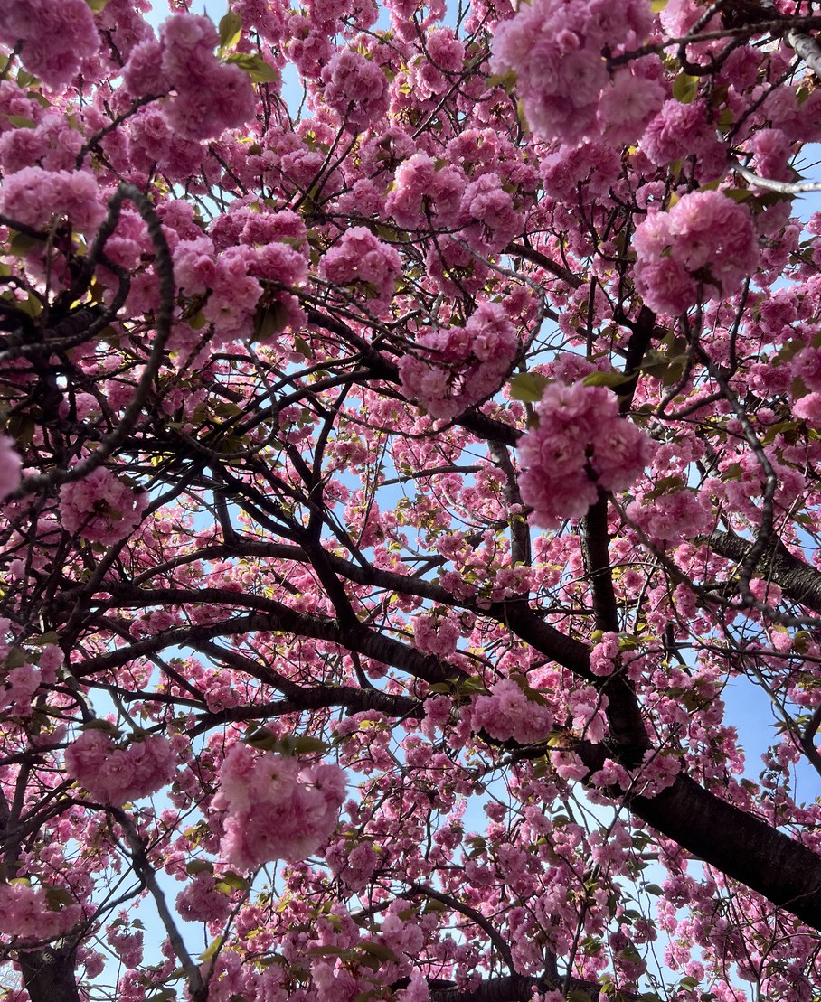
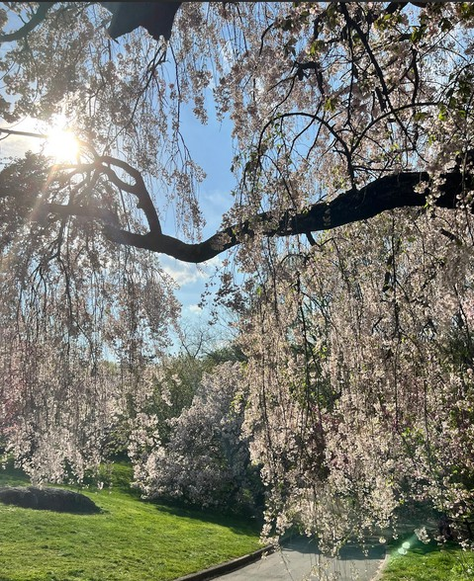
Photographs of Spring Belle Lin

12

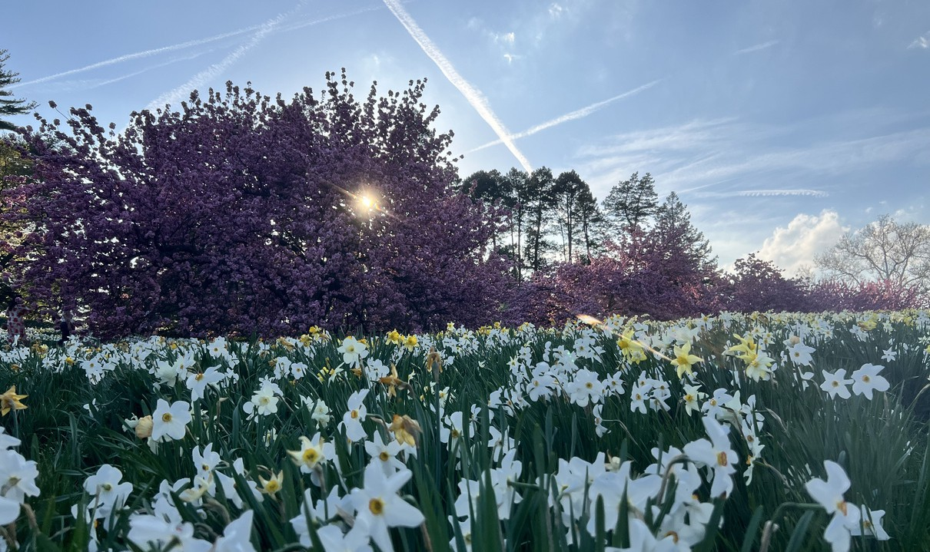
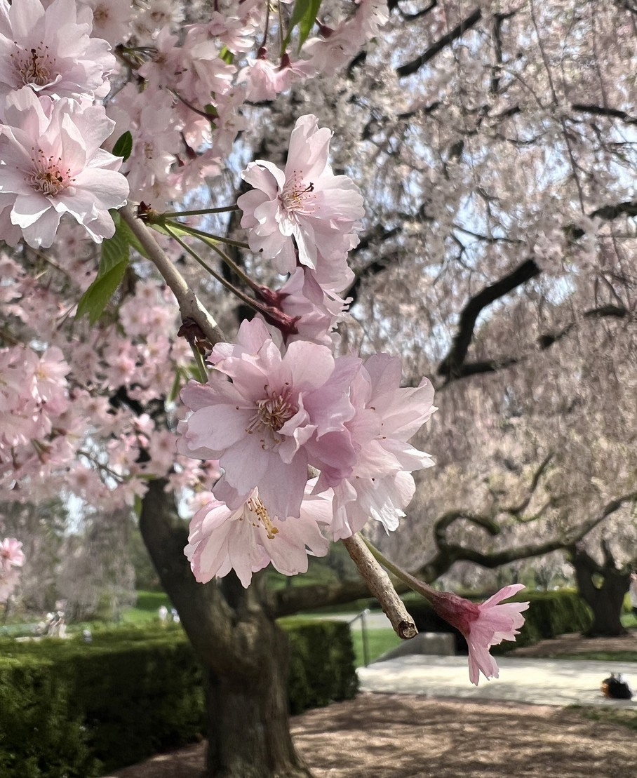
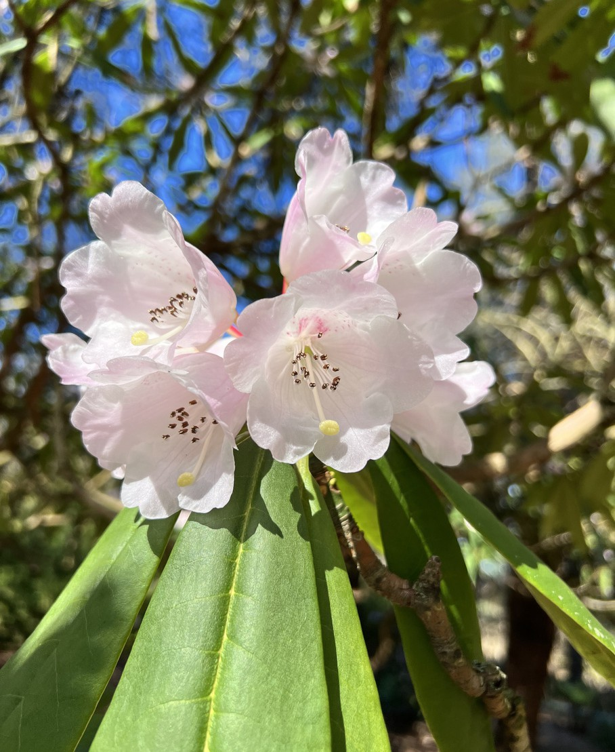
Photographs of Spring Belle Lin
13

ANOTHER SIDE
A 55-Word Story

Becka Jill Konnayil

“It should be spring by now,” I muttered again while walking into the hospital tightly gripping my jacket.

During pre-rounds, a wide-eyed little girl grabbed my hand after her exam and asked, “It’s still cold out, right?”

Before I could groan in agreement, she added, “I really want to see the flowers bloom this year!”

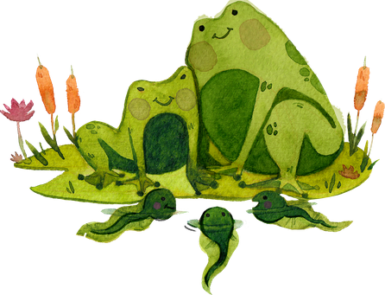

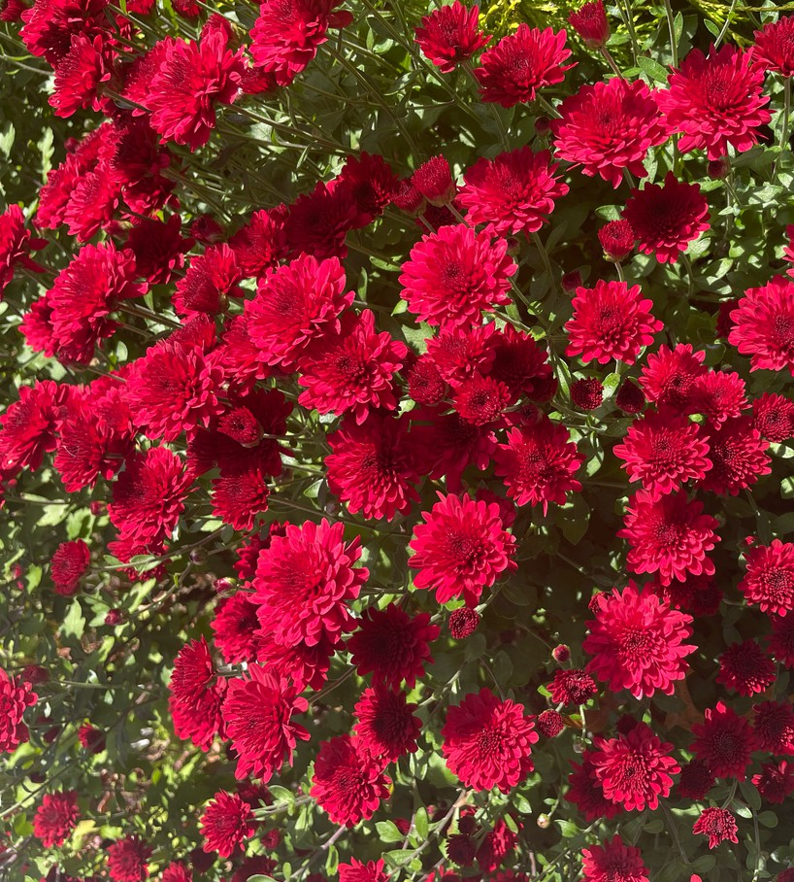

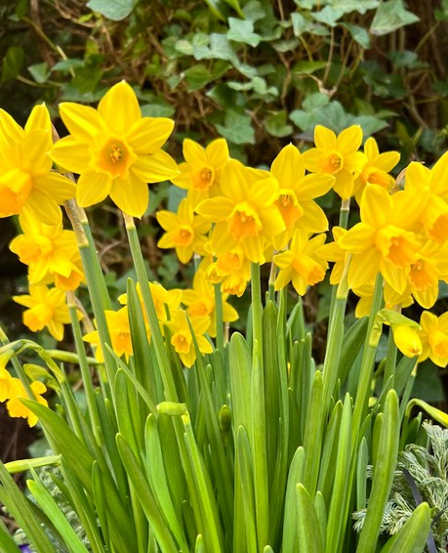
Photographs of Spring Belle Lin

14


MEET YOURSELF
Michael L Petagna

Today, I had the privilege of sharing deep vulnerability with my classmates. Nine of us familiar with each other, fond of one another, but not innately intertwined. Yet in that space, and in those moments, we connected on a fundamentally human level.

All of us successful, brilliant, promising, caring, and cared for. We see each other day after day, wearing our masks of confidence. And yet, many of us battling, intermittently or consistently, deep-seated self-doubt and feelings of inadequacy. Doubts perpetuated by false narratives told to us by our own worst critic - ourselves.

If any one of us had asked the person sitting to our left or right whether we were destined for success, the answer would have come without hesitation. Yes, success in the general sense. But more importantly, success in carrying goodness in our hearts and offering it up - marrying competency and compassion to touch the lives of the patients we encounter in their most vulnerable moments. We see this in each other.

So why don’t we see this in ourselves?

Maybe it’s because we wage a constant tug-of-war - an eternal battle between striving for excellence and meeting ourselves where we are. We spoke at length about our desires for balance and time for intentional self-care. As if these concepts were foreign, pipedreams, or rewards that we did not deserve unless we earned them. Because somewhere along the way, we convinced ourselves that perfection was the standard and that our failures should be met with shame. The cost of this is our minds and our spirits.

I’ve read that we can quiet this inner critic by separating our self-worth from our wins. By grounding ourselves in our values and our purpose. By tying our identity not to what we do, but to who we want to be. In doing so, we free ourselves to confidently use the gifts we have been given and to pass them along.

If this resonates with you, it might be time to meet yourself. The version of you that doesn’t require approval, seek to impress, or degrade itself. Perfectly yourself.

I’m still looking for myself. Maybe we can help each other.

15

Warmer weather awaits!
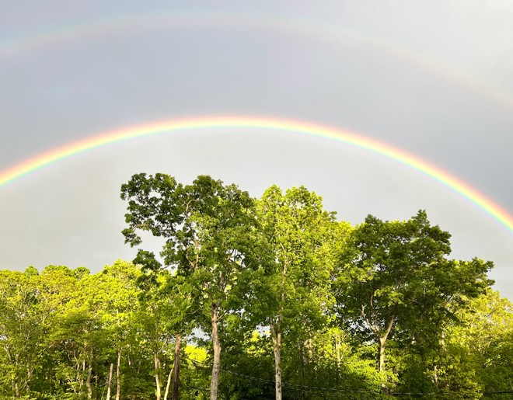
Photograph by Belle Lin

CHECK OUT OUR WEBSITE TO SEE ALL OUR PUBLISHED WORKS!



HTTPS://RENAISSANCE.STONYBROOKMEDICINE.EDU/UGME/ MESH-NEWSLETTER

