Content Outline for SEARCHING class

Recap from PICO class - why EBM is important to you?
(Motivation)
- You want to do the best thing for your patient; you know that you can’t remember everything you’ve learned, and what you’ve learned is becoming obsolete in front of your very eyes….
- The solution: A quick, easy and reliable skill, a way to get to what you need to know - - that will stay with you for the rest of your career!
- Slawson and Shaughnessy’s “Usefulness equation”:
Usefulness of medical information = Relevance x validity
Work

Overview
- We need easy, accessible and reliable ways to find the information we need to provide the best care for our patients
- With the Internet, we have an enormous databank of medical literature at our fingertips. We need to learn to utilize this information well.
- Developing facility with searching the literature in an effective and efficient manner will provide us with skills we can use for the rest of our lives; it will make us better physicians.
Objective
Given a question in the PICO format, you will be able to complete an appropriate and efficient search of the literature to answer your question (note – this is not to be confused with an exhaustive literature search, such as you might do in preparation for a research project)

Agenda
- Intro
  - Basic EBM (again) with review of PICO practice cases
  - Orientation to our electronic resources, EBM tutorials, links, etc.
  - Broad steps of EBM
  - Algorithm (appendix M), Searching table (appendix N)
  - Basic steps of EBM (Case together: appendix H)
- Cases to practice (appendix I)
- “Test” cases (appendix J)

Re-Introduction to EBM
- Remember background vs. foreground information (ask them to define)
  - Background information is sought when the question asks for general knowledge about a particular problem, single disease or concept (what is the disorder, what causes it, what is the clinical presentation, etc, what are some treatment options?) Background questions are often best answered with a textbook.
    - Background resources include: Any online or updated textbook, such as AccessMedicine, Books@Ovid, PsychiatryOnline, Stat!Ref, Up-To-Date, MD Consult or EMedicine
  - Foreground information involves specific questions regarding specific patients. These questions are more complex; they compare two things (ex: drugs, treatments or prognosis). These are the questions we put into PICO format to search for the best evidence.
    - Foreground resources include: Cochrane database, PubMed, Web of Science, etc.
- Levels of evidence (the Evidence Pyramid)
    - The best options: In a systematic review, the authors ask a specific clinical question, perform a comprehensive literature search, include only the well-done studies and make practice recommendations on the best evidence. A meta-analysis is a systematic review that combines all the results of all the studies into a single statistical analysis of results.

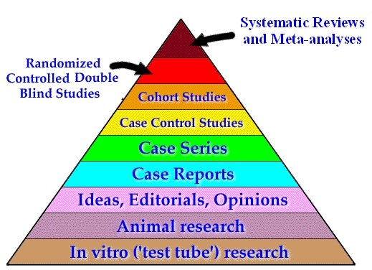

Navigating the HSC library web page (Librarian’s introduction - with emphasis on EBM resources, how to get to various tutorials, Cochrane and PubMed)
http://www.hsclib.sunysb.edu/index.php?option=com_frontpage&Itemid=1

Broad steps of Searching
- PICO question defines your issues of importance
  - Define your question
  - Choose your database
  - Secondary vs. Primary sources
- Determine the kind of search that is most appropriate
a. Secondary Sources –Summaries and analyses of the evidence derived from primary sources; someone else (whom you can rely on) has done the work for you. This is often the fastest (and easiest) place to start. (we will be only touching on these, as they are fairly easy to navigate)
- Essential Evidence Plus (used to be InfoPOEMS), http://www.essentialevidenceplus.com/
- Database of Abstracts of Reviews of Effects (DARE)
- TRIP database www.tripdatabase.com
  - Allows you to search several of the databases simultaneously
- Cochrane library www.cochrane.org
  - A good source for systematic reviews (especially therapy articles)
- Guidelines (though not all evidence-based)
  - National Guideline clearinghouse (http://www.guideline.gov)
  - AAP guidelines
- Evidence-based summaries
  - Clinical evidence
http://clinicalevidence.bmj.com/ceweb/index.jspe
  - Primary Sources: Direct evidence concerning a topic of interest, generally articles that appear in peer-reviewed journals; the huge body of literature available through various databases. We will be focusing on PubMed Clinical Queries and PubMed MeSH
- PubMed (MEDLINE) www.ncbi.nlm.nih.gov/pubmed/

The Basic Steps: Searching the Literature Quickly and efficiently (we will go through this with practice case, appendix H; they are given the searching algorithm and table, appendices M & N)
- Secondary Sources
  - Try one key word first (the crux of what you are looking for)
Example: Acne treatment → look for acne
May set limits to refine your results (adolescent, eg)

- PubMed Clinical Queries
    - Use the built-in filters for: diagnosis; etiology; prognosis; therapy; clinical prediction guides
    - Choose preference for: narrow search (specific, may miss some) vs. broad search (sensitive, but obtain more irrelevant articles.)
    - Question still not answered? Do advanced search
      - Focus vs. Expand using AND; NOT; OR
      - Use limits
        - Restrict by publication type, year, language, study type, age, etc.

  - PubMed – searching with MeSH (Medical Subject Heading)
- Search one term at a time and then combine
      - Click on the term you want and choose subheading(s)
      - Choose your limits
      - Send “to Search Box with AND”
      - Search, and then review results
      - Choose your next term, subheadings and combine
- Question still not answered? Do advanced search
Focus vs. Expand using AND; NOT; OR
Use limits: Restrict by publication type, year, language, study type, age,

Practice amongst yourselves with three cases (appendix I); use the algorithm and checklist for guidance; fill out the worksheet
Three “test” cases (appendix J) use the algorithm, table and checklist for guidance; fill out the worksheet

Next step: Answer your own questions!
Orientation to the three independent searches, using the worksheet, algorithm and table, and checklist.

