**How to Access the Research IT services used for shared drives, IT consults, data requests or application support (TriNetX, REDCap)**

Go to the Pulse

Right hand side of screen—Submit IT ticket request-takes you to Cherwell login screen

Log into that screen using your log info

Then click Request services

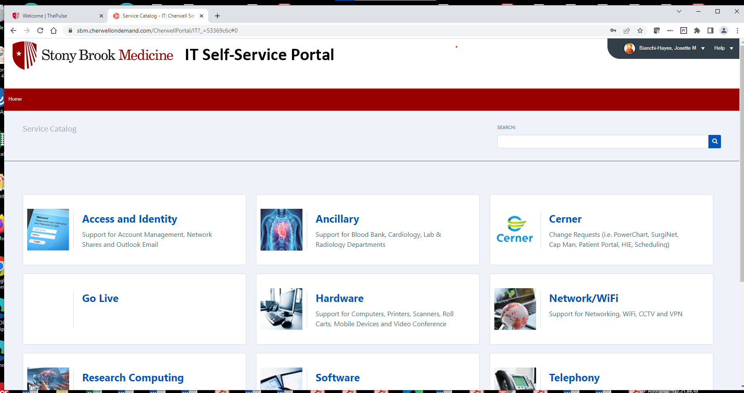

Then research computing

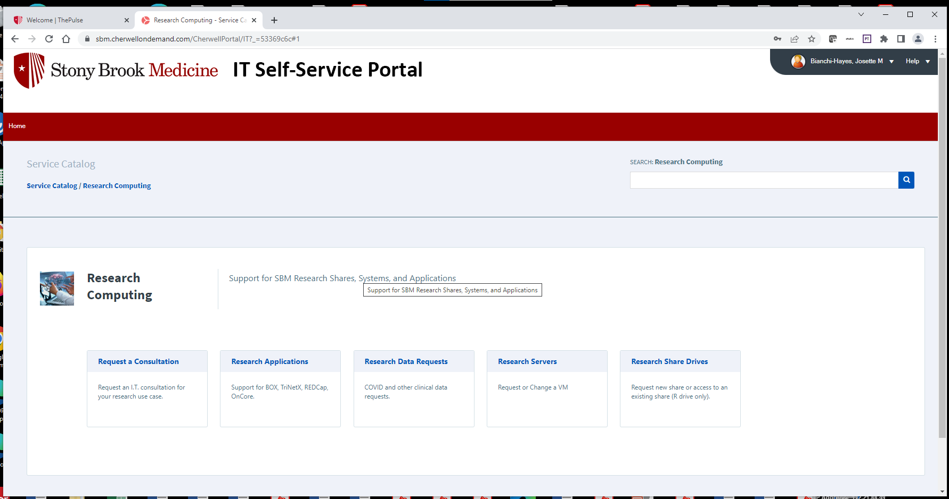

Choose which service you’d like.

Each team getting data should request a research shared drive to store data as a starting point.