

**Monoclonal Antibody (mAb) Infusion for COVID+ Patients**

**Instructions & Forms**

Page

1. **FAQ for ordering MDs** 2 - 4
2. **INSTRUCTIONS** 5
3. **REQUIRED FORMS:**
4. **CHECKLIST**: ***(required****)*

COVID-19 Monoclonal Antibody Checklist 6 - 7

1. **ORDERS**: *(****both are required****)*
   1. COVID+ Monoclonal Antibody Order 8
   2. Hypersensitivity Reactions Order 9
2. **CONSENT FORMS**: *(****one is required****)*
   1. Monoclonal Antibody Consent *(English)* 10
   2. Monoclonal Antibody Consent *(Spanish)* 11
   3. Monoclonal Antibody Consent *(prefilled for phone consents)* 12

**Questions**

* **SCHEDULING AND ADMINISTRATIVE QUESTIONS***:*

*PLEASE CALL CAROLYN OTTAKA AT 631-216-2767 OR CELL: 631-495-5059*

* **CLINICAL QUESTIONS ABOUT THE ANTIBODY THERAPY**:

*PLEASE CALL 631-444-1099 AND ASK FOR THE ANTIMICROBIAL STEWARDSHIP PHYSICIAN FOR COVID ANTIBODIES*

emailsig **FAQ for ordering MDs**

**What are the COVID monoclonal antibodies (mAbs)?**

These are manufactured antibodies that target the spike protein of SARS-CoV2. Attacking the spike protein can block viral entry into human cells. The FDA has granted emergency use authorization (EUA) for COVID mAbs for the treatment of mild-moderate COVID disease. Stony Brook Medicine is currently offering **casirivimab-imdevimab,** **bamlanivimab-etesevimab, and sotrovimab.**

**How efficacious are these mAbs?**

COVID mAbs have been shown in clinical trials to reduce symptoms and as well as hospitalizations and emergency room visits by approximately 70% when given early in the course of the disease. In the casirivimab-imdevimab trial, there was a reduction in COVID-19 related hospitalizations (3% vs. 9% in the placebo). Casirivimab-imdevimab has also been shown to decrease the risk of symptomatic disease when given to household contacts of persons infected with SARS-CoV2 by 81%. **Efficacy will vary based on the SARS-CoV2 variant; both bamlanivimab-etesevimab and casirivimab-imdevimab are not efficacious against the Omicron variant.**

**Who should get the COVID mAbs?**

Due to the high demand for COVID mAb treatment, the following criteria is used:

Patients be age 12 years or older, weigh at least 40 kg, have a positive COVID test, and have symptoms for 5 days or less. ***Eligible patients must fall under the 1A Risk Group in the NYSDOH Priority Framework:***

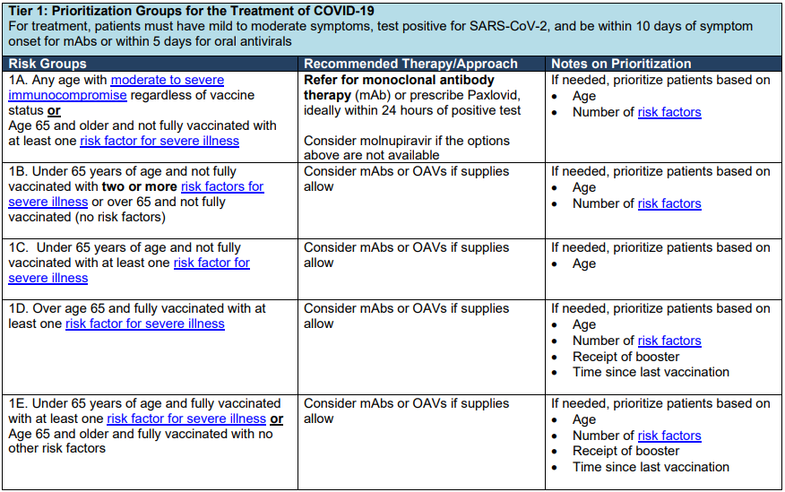

*Fully vaccinated: (1) receipt of three doses of a COVID vaccine or (2) receipt of two doses of either Pfizer or Moderna vaccines with the second dose being in the last six months.

COVID mAbs are **not** approved for use in the following:

* Persons hospitalized due to COVID-19
* Persons on oxygen therapy due to COVID-19
* Persons who require an increase in baseline oxygen flow rate due to COVID-19 in those on chronic oxygen therapy due to underlying non-COVID-19 related comorbidity

No dosage adjustments are needed based on age, weight, gender, or underlying kidney or liver disease.

Except potentially with the COVID vaccine (see below), there are no known drug interactions involving these mAbs.

*Note: COVID mAbs for postexposure prophylaxis will not be offered as priority will be given to persons with acute infection while there are drug shortages.*

**If my patient does not fit the above criteria, can she get a COVID mAb treatment at Stony Brook?**

No. We are following the criteria as outlined above.

**What if my patient is pregnant?**

The FDA has expanded the EUA to include pregnant women as a group at high risk of progression to severe disease. Pregnant women must meet the above criteria to be eligible for mAbs.

**What are the side effects to these mAbs?**

COVID mAbs have been found to be very safe. Infusion reactions, allergic reactions, and anaphylaxis have been reported. Patients have also reported fever, nausea, and headache. Because of these potential side effects, patients are monitored for one hour are the infusion. The site will be prepared with medications to treat hypersensitivity reactions if they occur.

**Are the mAbs effective against the SARS-CoV2 variants of concern (i.e. delta, omicron)?**

*In vitro* data suggests that mAbs will be effective against the delta variant but will be ineffective against the omicron variant.

|  |  |  |  |
| --- | --- | --- | --- |
|  | **COVID Variant** | | |
|  | **Alpha** | **Delta** | **Omicron** |
| Bamlanimvimab-etesevimab | **Not effective** | Effective | **Not effective** |
| Casirivimab-imdevimab | Effective | Effective | **Not effective** |
| Sotrovimab | Effective | Effective | Effective |

**If my patient gets a mAb, can they also get other COVID related therapies (i.e. remdesivir, dexamethasone) later?**

Yes. Getting a mAb does not exclude one from getting any of the FDA authorized therapies for COVID-19.

**If my patient gets a mAb, can they also get the COVID vaccine?**

There is a risk of interference with the mAbs and the vaccine. It is recommended that persons who receive a COVID mAb treatment wait at least 90 days from the infusion before getting a COVID vaccine.

**If my patient had a COVID vaccine, can they get a mAb?**

Yes. Prior receipt of a COVID vaccine does not exclude one from getting a mAb as long as she meets the use criteria.

**I am still not sure if my patient should get a mAb. What can I do?**

Stony Brook Infectious Diseases can provide a telehealth consultation for your patient to help determine eligibility. Please call the Scheduling number in the box below for this to be arranged.

**My patient meets eligibility criteria. How does my patient get a COVID mAb at Stony Brook?**

Please use the 3 required forms (checklist, orders and consent) contained in this package.

**QUESTIONS?**

**SCHEDULING & ADMINISTRATIVE QUESTIONS:**  *PLEASE CALL CAROLYN OTTAKA 631-216-2767 OR CELL 631-495-5059*

**CLINICAL QUESTIONS*:*** *PLEASE CALL 631-444-1099 AND ASK FOR THE ANTIMICROBIAL STEWARDSHIP PHYSICIAN FOR COVID ANTIBODIES*



## INSTRUCTIONS

## How to Order Monoclonal Antibody Infusion Therapy for COVID+ Patients

1. **PATIENTS IDENTIFIED BY SBUH PROVIDERS:**

Please complete:

* 1. COVID-19 Monoclonal Antibody Administration Checklist *(REQUIRED)*
  2. COVID+ Monoclonal Antibody order form *(REQUIRED)*
  3. Hypersensitivity order form (*REQUIRED)*
  4. Monoclonal Antibody consent form *(REQUIRED - includes example for phone consents)*

Fax to: “ATTENTION: COVID INFUSION” to 631-216-2944.

1. **PRE-VISIT INSURANCE ELIGIBILITY AND AUTHORIZATION**: Stony Brook Cancer Center (SBCC) Authorization Team will obtain all necessary approvals, as appropriate.

### **SCHEDULING:** The SBCC scheduler will contact the patient and provide specific instructions and directions to the ACP (rear) entrance. Patients will be scheduled immediately, between 10:00AM and 5:00PM, Monday - Friday.

1. **REGISTRATION:** The SBCC scheduler will inform Patient Accessto perform pre-registration of the encounter. On- site arrival and check-in will be remote and touchless. Patients will be provided with instructions.

**QUESTIONS**

* ***SCHEDULING AND ADMINISTRATIVE QUESTIONS:***  *PLEASE CALL CAROLYN OTTAKA AT 631-216-2767 OR CELL 631-495-5059*
* ***CLINICAL QUESTIONS ABOUT THE ANTIBODY THERAPY:*** *PLEASE CALL 631-444-1099 AND ASK FOR THE ANTIMICROBIAL STEWARDSHIP PHYSICIAN FOR COVID ANTIBODIES*

## COVID-19 MONOCLONAL ANTIBODY ADMINISTRATION CHECKLIST



**Location of patient:**

**ED ACP Other: Home**

**Name of Patient:**

**MRN:**

##### COMPLETE ALL FIELDS BEFORE ORDERING:

##### Patient Vaccination Status

Fully Vaccinated (Date of 3rd vaccine dose)

##### Unvaccinated/Not Fully Vaccinated* Pfizer Date ______ Moderna Date _______

##### INDICATION FOR USE (Complete the required information in one column):

|  |
| --- |
| Treatment of Mild-Moderate COVID-19Date of first symptoms (onset must be within 5 days):Click or tap to enter a date.Date of positive COVID test:Click or tap to enter a date. |

##### Patient Risk Factors (Please check all that apply):

**Patient must be at least 12 years of age *and* weight over 40 kg**

**AND the patient must belong to one of the following risk groups (select one):**

Moderate to severe immunocompromise state

Age 65 years and older, not fully vaccinated, with **at least ONE of the following**:

Obesity (adults with BMI >30 kg/m2, or if age 12-17, have BMI ≥85th percentile for their age and gender based on CDC growth charts, <https://www.cdc.gov/growthcharts/clinical_charts.htm>)

Pregnancy

Chronic kidney disease

Diabetes

Immunosuppressive disease or immunosuppressive treatment

Cardiovascular disease (including congenital heart disease) or hypertension

Chronic lung diseases

Sickle cell disease

Neurodevelopmental disorders (for example, cerebral palsy)

Having a medical-related technological dependence (i.e., tracheostomy, gastrostomy, or positive pressure ventilation (not related to COVID-19))

*Fully vaccinated: (1) receipt of three doses of a COVID vaccine or (2) receipt of two doses of either Pfizer or Moderna vaccines with the second dose being in the last six months.

**DO NOT ORDER MONOCLONAL AB IF:**

* Patient requires supplemental oxygen due to COVID-19 infection
* Patient required an increase in baseline oxygen flow rate due to COVID-19 in patients on chronic supplemental oxygen due to underlying non-COVID-19 co-morbidity
  + - * 1. **Ordering Provider**:

Name of ordering physician: *_______________________________ (please print)* ***MUST***

***BE*** Cell: _________________________________________ ***COMPLETED***

**IMPORTANT:**

**ORDERS FOR OUTPATIENT INFUSIONS (NON- ED):**

**To schedule:** Please faxall completed forms: “ATTENTION: COVID INFUSION” to 631-216-2944**.**

**For scheduling questions**: Please call Carolyn Ottaka (office 631-216-2767 or cell 631-495-5059) or Barbara McByrne (cell 631-459-1234).

**For clinical questions**: Please call 631-444-1099 and ask for the Antimicrobial Stewardship Physician for COVID antibodies.

**ORDERS FROM THE EMERGENCY DEPARTMENT:** You must call the pharmacy (444-2680) to alert them that you are sending a checklist to order Casirivimab-Imdevimab. Then this checklist (up to this point) must be sent to Pharmacy at [**SBUH_Pharmacy_Leadership@stonybrookmedicine.edu**](mailto:SBUH_Pharmacy_Leadership@stonybrookmedicine.edu)  to confirm drug availability.