Pediatric Seizure (Status Epilepticus) (Uploaded on 9/24/2023)

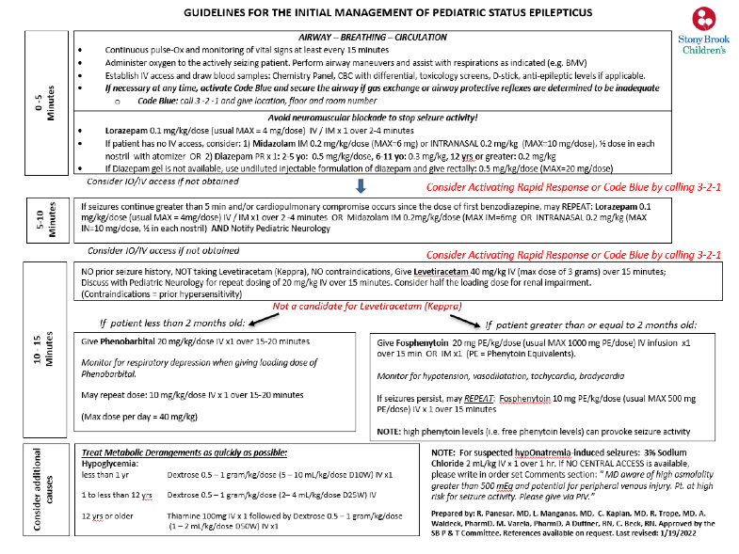
3/2022

