**Use of the Kaiser Sepsis Calculator**

Criteria for Screening/Early Onset Sepsis (EOS) Risk Factors:

* Gestational age <37 weeks (but also ≥34 weeks)
* Prolonged ROM (≥18 hours)
* Maternal antepartum fever (≥38C)
* Maternal GBS positive status (regardless of treatment)
* Need for resuscitation/signs of clinical illness at birth
* Consider for vital sign or clinical exam abnormalities in the first 24 HOL

Timing of Screening:

* Upon admission to the Newborn Nursery for asymptomatic newborns with EOS risk factors
* Immediately for symptomatic newborns

Personnel:

* Admitting Mother-Baby RN to notify on call MD of any infant with 1 or more risk factors for EOS as listed above. NICU to be notified on L&D if infant with abnormal vital signs or clinical exam abnormalities, or a diagnosis of maternal chorioamnionitis/intraamniotic infection.
* KSS score to be calculated by pediatric resident, NP or attending physician

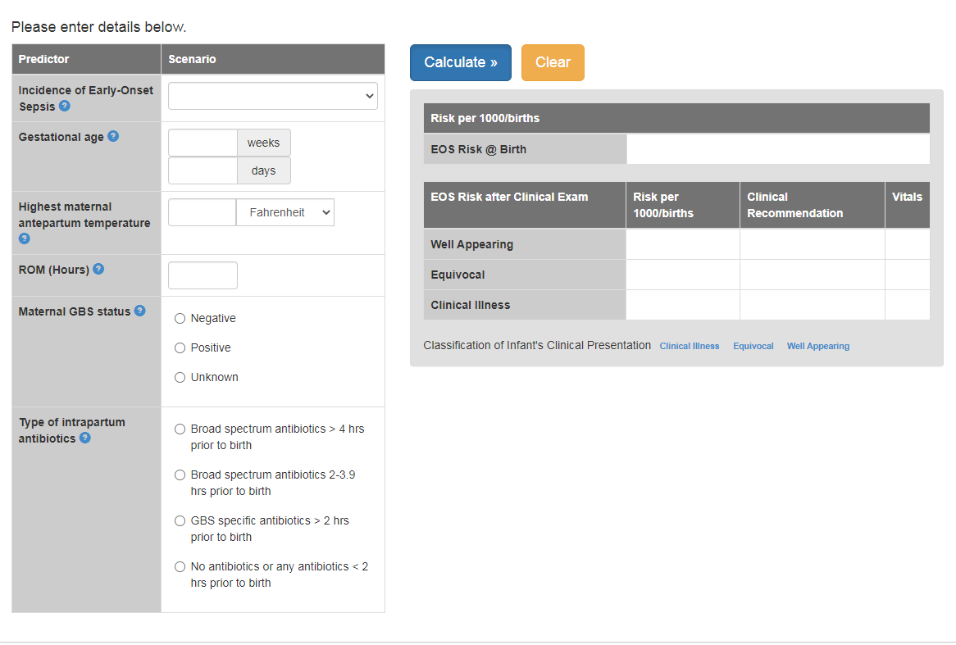

How to answer each Predictor/Scenario pairing

1. Incidence of Early-Onset Sepsis

* Choose 0.6/1000 live births (At Stony Brook hospital we have chosen a more conservative incidence rate to minimize risk of not identifying infants with EOS)

1. Gestational Age

* Enter in weeks and days

1. Highest maternal antepartum temperature

* Defined as highest maternal temperature up **until the time of delivery** (*If mother with a temperature up to 1hr post-delivery, OB should be notified and NICU consulted if there is clinical concern for chorioamnionitis/intraamniotic infection)
* Enter in degrees Celsius

1. ROM (hours)

* Round to the nearest hour

1. Maternal GBS status

* Choose based on mother’s result: positive/negative/unknown

1. Type of intrapartum antibiotics

* GBS specific antibiotics = penicillin, ampicillin or cefazolin
* **Vanc and Clinda (if given for GBS+ mother w/ PCN allergy) = NO ANTIBIOTICS or any antibiotics < 2 hours prior to birth (*****This is not broad spectrum abx treatment****)**
* **Erythromycin is ineffective = no antibiotics**
* Broad-spectrum antibiotics = other cephalosporins, fluoquniolones, piperacillin/tazobactam, carbapenems or any combination of antibiotics that includes an aminoglycoside or metronidazole.

Clinical Assessment of infant

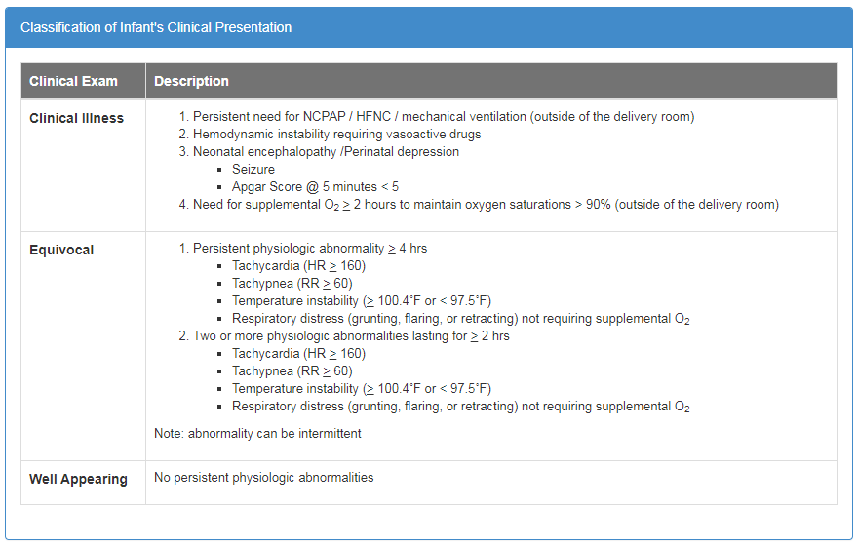

Interpretation of EOS Risk Score Results and Infant Management:

1. Management Plan for GREEN Group:
   1. Routine care.
2. Management Plan for YELLOW Group:
   1. If Recommendations Require BLOOD CULTURE AND OBSERVATION 🡪 **Transfer to NICU**
   2. Occasionally, with borderline elevated risk the EOS calculator may indicate ‘Yellow – observation only. These infants may be observed in the Newborn Nursery with **q3-4 hours vital sign monitoring**
   3. If abnormal clinical parameters develop, the infant requires urgent MD evaluation
   4. **If equivocal signs develop, infant requires transfer to NICU**
3. Management Plan for RED Group:
   1. **NICU Admission**

**\*\*Maternal chorioamnionits is diagnosed by the Obstetrics department and those infants are admitted to NICU for evaluation.**